Supplementary material

Supplementary Table 1: Demographic variables and clinical measures of the participants. Table lists median and interquartilerange (IQR) of age, mRS at scan, and disease duration. Treatment, medication, and psychiatric symptoms during disease course were evaluated using a binary (present: ‘yes’ vs. absent: ‘no’) scale. Disease duration = days in hospitalization during acute phase of the disease; N = number of subjects; NMDARE = anti-NMDA receptor encephalitis.
 |  | NMDARE Patients | Healthy Controls
N |  | 57 | 61
Sex | ♀ / ♂ | 50/7 | 54/7
Age (years) | Median ± IQR (N) | 25.00 ± 14.50 (57) | 26.00 ± 11.00 (61)
mRS at scan | Median ± IQR (N) | 1.00 ± 1.00 (55) | ..
Disease duration  (days in hospitalization) | Median ± IQR (N) | 62.00 ± 59.50 (52) | ··
Years between disease onset and scan | Median ± IQR (N) | 2.43 ± 2.95 (50) | ..
First-line treatment | yes/no | 56/1 | ··
Second-line treatment | yes/no | 28/29 | ··
Anticonvulsant medication | yes/no | 41/16 | ··
Antipsychotic medication | yes/no | 41/16 | ··
Positive symptoms | yes/no | 28/29 | ··
Negative symptoms | yes/no | 18/39 | ··

Supplementary Table 2: Location of included independent components. Component numbers, component labels, maximum t-value, MNI-coordinates of peak voxel and number of voxels in each component counting the voxels that contain the 60% highest values.
Somatomotor network
6 | Postcentral gyrus (right) | 4.02 | [58 -18 48] | 2731
15 | Superior temporal gyrus (right) | 3.63 | [68 -32 10] | 1268
23 | Supplementary motor area (bil.) | 4.11 | [-2 -18 62] | 1930
44 | Superior temporal gyrus (bil.) | 3.67 | [48 0 -2] | 2814
78 | Precentral gyrus (bil.) | 4.14 | [-41 -20 63] | 751
Visual network
11 | Calcarine fissure (bil.) | 4.09 | [-10 -94 -4] | 4690
38 | Temporo-parietal-occipital junction (right) | 4.17 | [62 -46 10] | 2033
87 | Middle occipital gyrus (bil.) | 1.42 | [-40 -92 -2] | 2620
90 | Superior occipital gyrus (bil.) | 3.86 | [-22 90 34] | 1251
Subcortical network
5 | Putamen (bil.) | 4.70 | [-22 10 -12] | 2249
92 | Caudate (bil.) | 3.21 | [-12 -6 18] | 1001
Cerebellar network
7 | Cerebellum (right) | 2.77 | [46 -50 -30] | 3120
Default mode network
13 | Angular gyrus (bil.) | 4.46 | [44 -74 40] | 2222
14 | Parahippocampal gyrus (right) | 4.04 | [-23 -25 -21] | 154
24 | Dorsolateral superior frontal gyrus (right) | 5.28 | [14 46 50] | 1008
33 | Medial prefrontal cortex (bil.) | 4.37 | [- 2 62 18] | 2394
36 | Medial prefrontal cortex (bil.) | 6.34 | [-2 68 2] | 564
40 | Superior temporal gyrus (left) | 2.82 | [-54 20 -6] | 1800
59 | Hippocampus (bil.) | 3.54 | [20 -16 -16] | 1270
61 | Superior frontal gyrus, medial orb (bil.) | 3.91 | [-2 58 -12] | 882
84 | Parietal lobe, angular gyrus (bil.) | 2.69 | [-50 -60 52] | 1597
85 | Inferior frontal gyrus, opercular part (left) | 3.05 | [-62 14 18] | 1487
Dorsal attention network
10 | Parieto-occipital sulcus (bil.) | 9.20 | [-2 -60 64] | 411
41 | Postcentral gyrus (left) | 5.84 | [48 -34 62] | 563
43 | Interparietal sulcus (right) | 6.13 | [44 -50 62] | 494
45 | Precuneus (bil.) | 2.99 | [-36 -74 40] | 2768
58 | Superior parietal gyrus (bil.) | 4.33 | [38 -52 60] | 2017
74 | Superior parietal gyrus (bil.) | 4.95 | [30 -68 56] | 875
80 | Parieto-occipital sulcus (right) | 6.55 | [4 -56 72] | 260
82 | Postcentral gyrus (right) | 3.89 | [28 -46 72] | 584
86 | Postcentral gyrus (bil.) | 3.46 | [-58 -6 40] | 3042
Frontoparietal network
12 | Inferior temporal gyrus (bil.) | 3.24 | [-64 -44 -14] | 1544
28 | Middle frontal gyrus, orbital part (right) | 3.67 | [44 48 -6] | 985
29 | Middle frontal gyrus, orbital part (left) | 3.43 | [-46 50 -4] | 1674
51 | Dorsolateral superior frontal gyrus (right) | 4.22 | [28 66 6] | 322
54 | Middle frontal gyrus (bil.) | 4.13 | [32 50 38] | 1533
71 | Inferior frontal gyrus, triangular part (bil.) | 3.66 | [-56 20 32] | 1800
89 | Superior frontal gyrus (left) | 5.83 | [-24 66 17] | 575
91 | Superior temporal gyrus (left) | 1.81 | [-54 20 -8] | 5643

Supplementary Table 3: Two-way ANOVA for overall connectivity. * indicates significant effect.
 | Sum of squares | Df | F | p
Main effect: group | 0.002 | 1 | 2.52 | 0.11
Main effect: state | 0.188 | 3 | 67.62 | <0.0001 *
Interaction effect | 0.004 | 3 | 1.58 | 0.19
Residuals | 0.268 | 290

Supplementary Table 4: Average windows-wise overall connectivity (± SD) across all subjects.
 | Mean (± SD)
State 1 | 0.23 (± 0.02)
State 2 | 0.27 (± 0.03)
State 3 | 0.30 (± 0.04)
State 4 | 0.24 (± 0.03)

Supplementary Table 5: Post-hoc Kruskal-Wallis test to examine state-wise differences in overall connectivity (Chi²=124.37, p < 0.0001, df =3). The table contains the Bonferroni-corrected p-values for pairwise state comparison.
State | p
State 1 - State 2 | < 0.0001
State 1 - State 3 | < 0.0001
State 1 - State 4 | 0.19
State 2 - State 3 | 0.11
State 2 - State 4 | < 0.0001
State 3 - State 4 | < 0.0001

Supplementary Table 6: Two-way ANOVA for modularity. * indicates significant effect.
 | Sum of squares | Df | F | p
Main effect: group | 0.012 | 1 | 3.16 | 0.076
Main effect: state | 1.113 | 3 | 98.11 | <0.0001 *
Interaction effect | 0.002 | 3 | 0.14 | 0.94
Residuals | 1.098 | 290

Supplementary Table 7: Average window-wise modularity (± SD) across all subjects.
 | Mean (± SD)
State 1 | 0.37 (± 0.06)
State 2 | 0.42 (± 0.07)
State 3 | 0.25 (± 0.05)
State 4 | 0.41 (± 0.07)

Supplementary Table 8: Post-hoc Kruskal-Wallis test to examine state-wise differences in modularity (Chi²=136.08, p < 0.0001, df =3). The table contains the Bonferroni-corrected p-values for pairwise state comparison.
State | p
State 1 - State 2 | < 0.0001
State 1 - State 3 | < 0.0001
State 1 - State 4 | 0.0070
State 2 - State 3 | < 0.0001
State 2 - State 4 | 1
State 3 - State 4 | < 0.0001

Supplementary Table 9: Group differences in occurrences of states. Group differences were calculated using the z-test for population proportions. * p < 0.05 (uncorrected). NMDARE = anti-NMDA receptor encephalitis.
 | State | NMDARE Patients  (N, %) | Healthy Controls  (N, %) | z | p_{uncorr}
Occurrence | 1 | N=49, 85.96% | N=55, 90.16% | 0.70 | 0.48
 | 2 | N=42, 73.68% | N=31, 50.82% | 2.34 | 0.019*
 | 3 | N=28, 49.12% | N=28, 45.90% | -0.35 | 0.73
 | 4 | N=34, 59.65% | N=31, 50.82% | -0.96 | 0.34

Supplementary Table 10: Two-way ANOVA for dwell time. * indicates significant effect.
 | Sum of squares | Df | F | p
Main effect: group | 23068.00 | 1 | 6.79 | 0.0096 *
Main effect: state | 68622.00 | 3 | 6.73 | 0.00021 *
Interaction effect | 20411.00 | 3 | 2.00 | 0.11
Residuals | 985147.00 | 290

Supplementary Table 11: Two-way ANOVA for transition frequencies. * indicates significant effect.
 | Sum of squares | Df | F | p
Main effect: group | 7.25 | 1 | 4.07 | 0.044 *
Main effect: state | 46.87 | 5 | 5.26 | <0.0001 *
Interaction effect | 9.20 | 5 | 1.03 | 0.40
Residuals | 1239.96 | 696

Supplementary Table 12: Two-way ANOVA for fraction time. * indicates significant effect.
 | Sum of squares | Df | F | p
Main effect: group | 0.036 | 1 | 0.35 | 0.56
Main effect: state | 1.515 | 3 | 4.94 | 0.0023 *
Interaction effect | 0.037 | 3 | 0.12 | 0.95
Residuals | 29.63 | 290

Supplementary Table 13: Differences between states in dwell time (windows), transition frequencies between states (absolute numbers), and fraction time (percentage). Differences between states were calculated using a Tukey’s test. T-values and p-values are shown. * p < 0.05 (FDR-corrected), ** p < 0.01 (FDR-corrected).
 | State | t | p_{FDR}
Dwell time | 1 - 2  1 - 3  1 - 4  2 - 3  2 - 4  3 - 4 | 3.77  3.61  1.86  -0.04  -1.69  -1.61 | 0.0011 **  0.0021 **  0.25  0.99  0.33  0.37
Transition frequency | 1 - 2 vs 1 - 3  1 - 2 vs 1 - 4  1 - 2 vs 2 - 3  1 - 2 vs 2 - 4  1 - 2 vs 3 - 4  1 - 3 vs 1 - 4  1 - 3 vs 2 - 3  1 - 3 vs 2 - 4  1 - 3 vs 3 - 4  1 - 4 vs 2 - 3  1 - 4 vs 2 - 4  1 - 4 vs 3 - 4  2 - 3 vs 2 - 4  2 - 3 vs 3 - 4  2 - 4 vs 3 - 4 | 0.00  -1.22  0.54  1.97  3.32  -1.22  0.54  1.97  3.32  1.76  3.19  4.55  1.42  2.78  1.357 | 1.00  0.83  0.99  0.36  0.012 *  0.83  0.99  0.36  0.012 *  0.49  0.019 *  0.00012 **  0.71  0.062  0.75
Fraction time | 1 - 2  1 - 3  1 - 4  2 - 3  2 - 4  3 - 4 | 3.226  3.017  2.170  -0.093  -0.934  -0.817 | 0.0075 **  0.015 *  0.13  0.99  0.79  0.85

Supplementary Table 14: Pearson’s correlation coefficient between the participants’ average static FC and the participants’ average of each state.
 | R
Static – State 1 | 0.94
Static – State 2 | 0.91
Static – State 3 | 0.87
Static – State 4 | 0.71

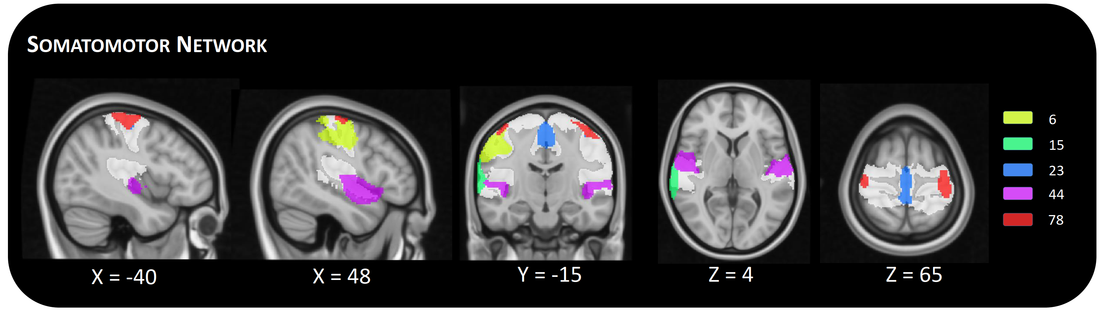
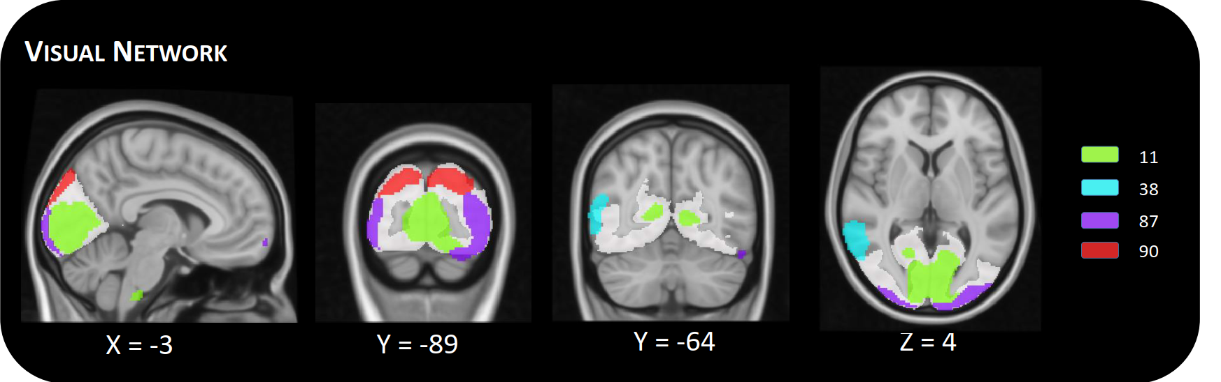
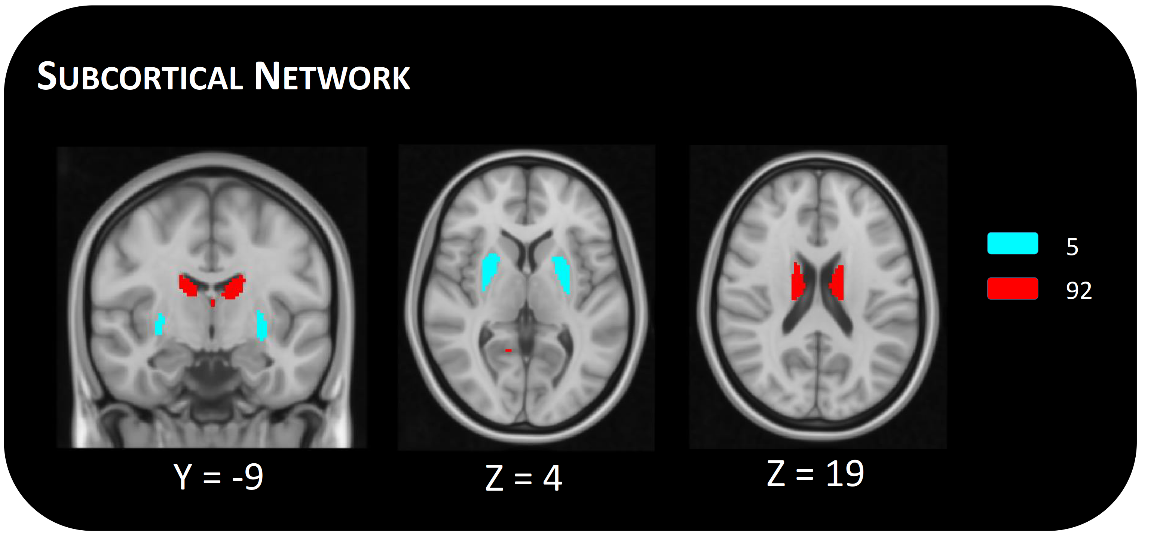
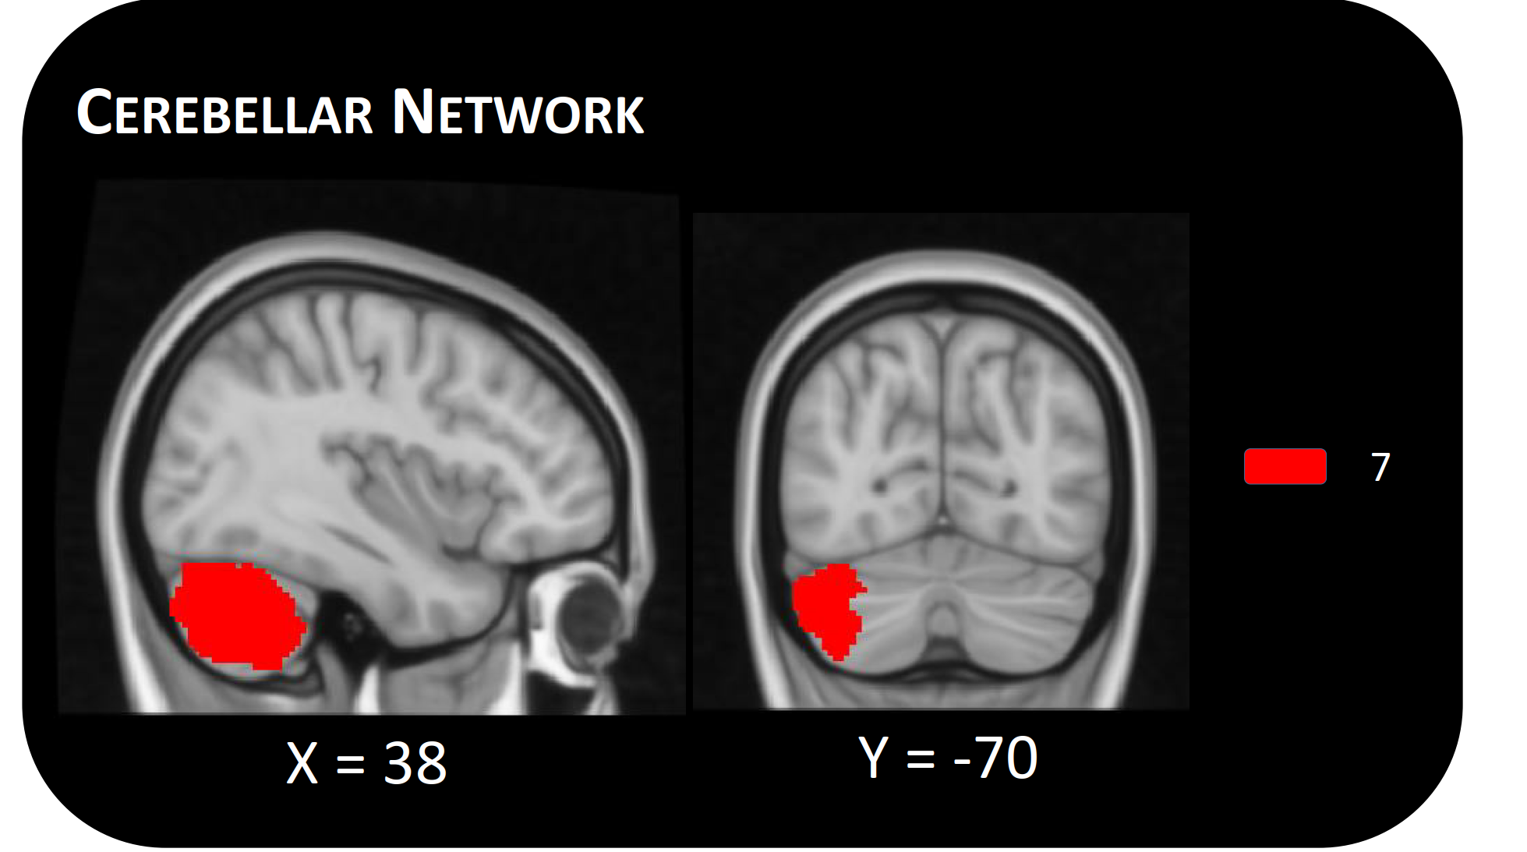
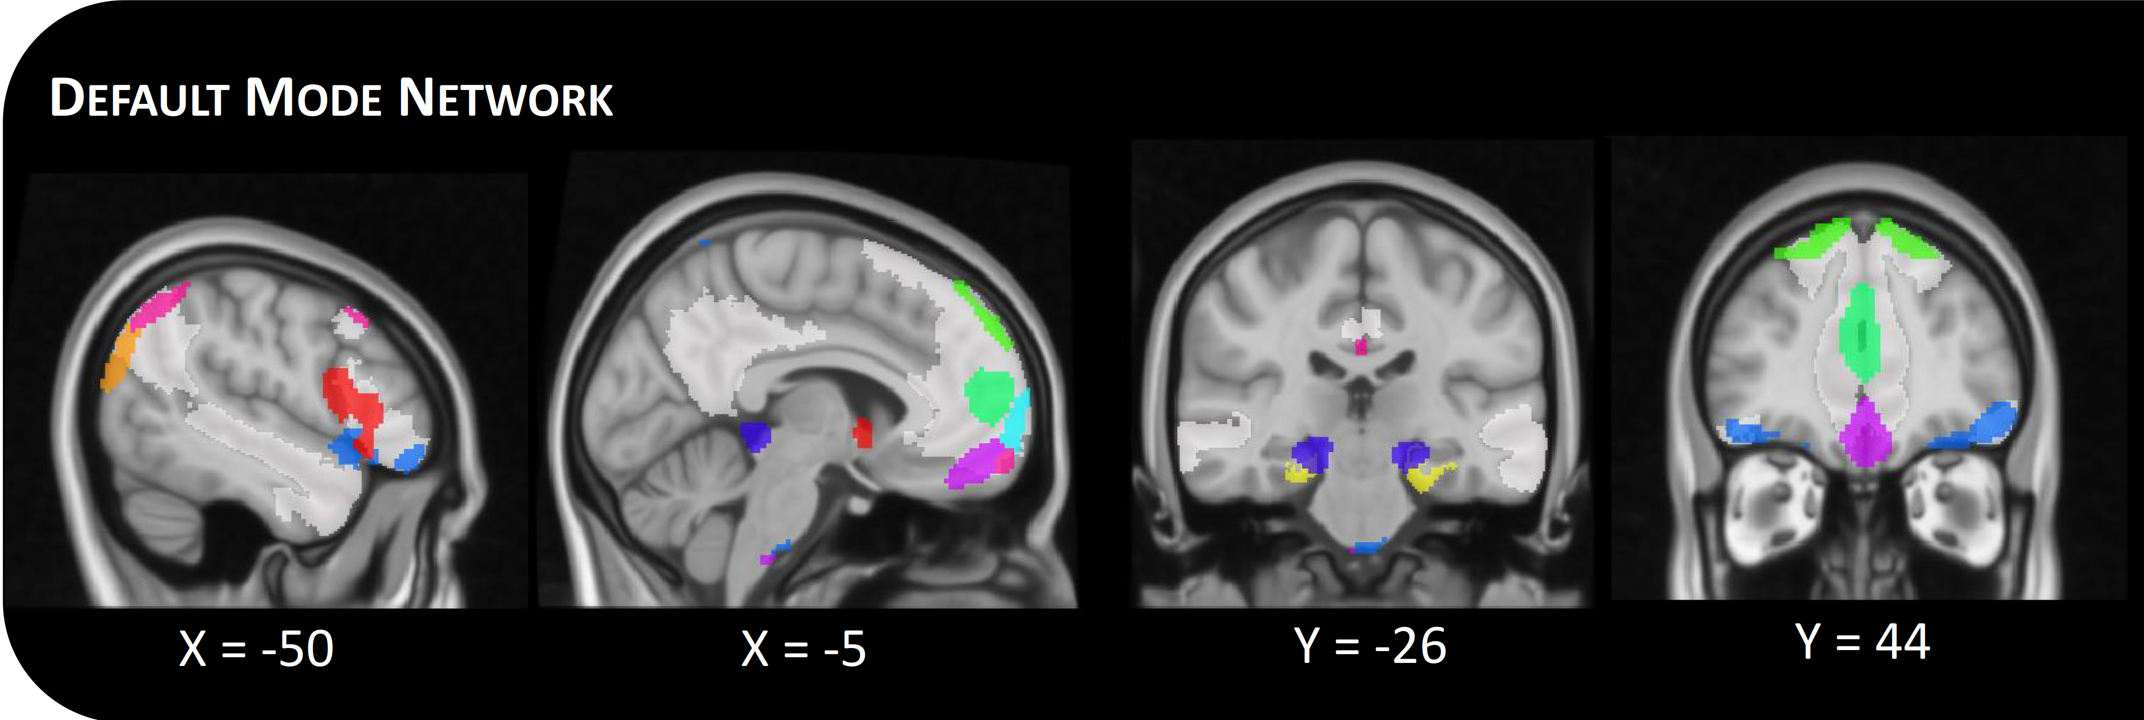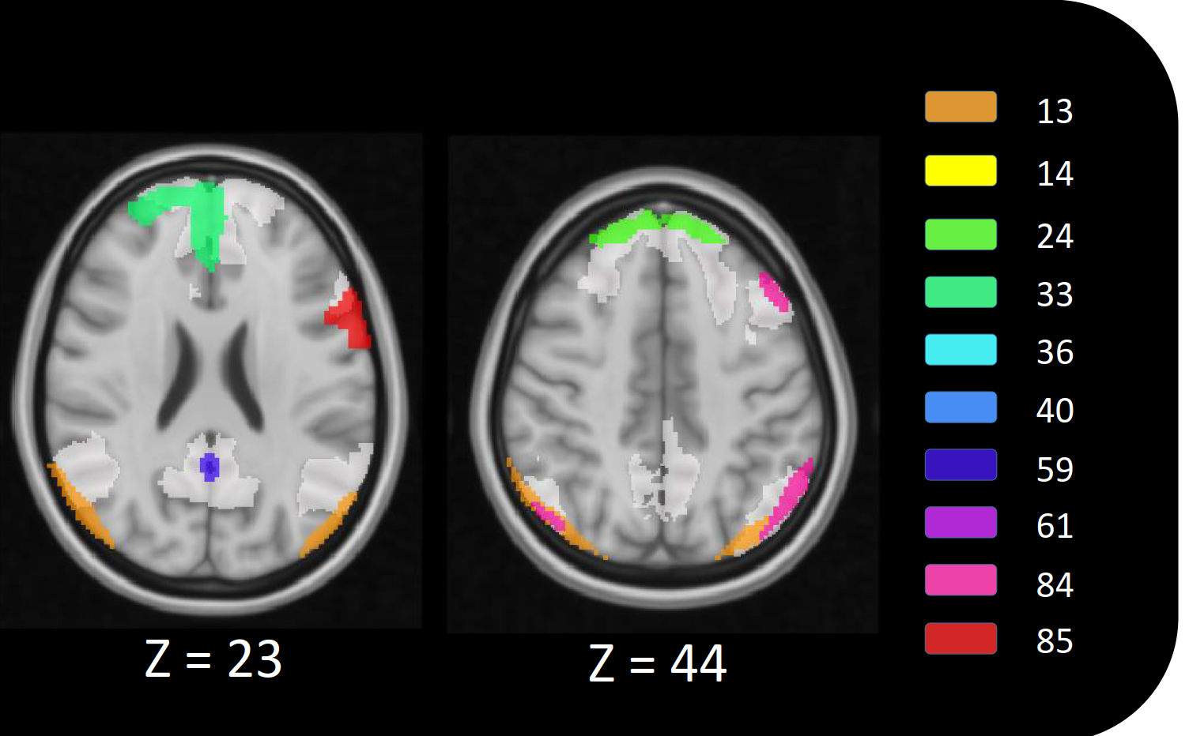
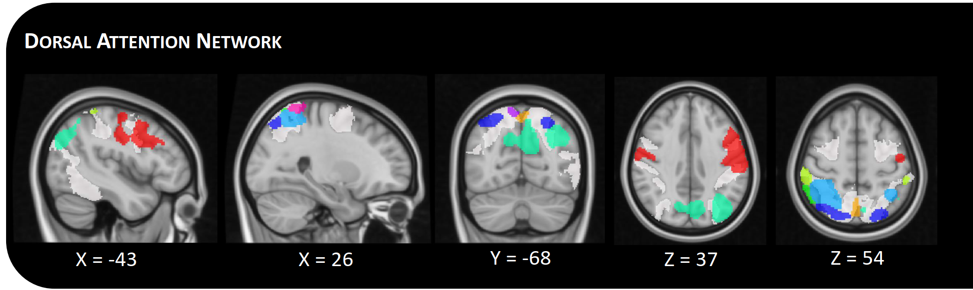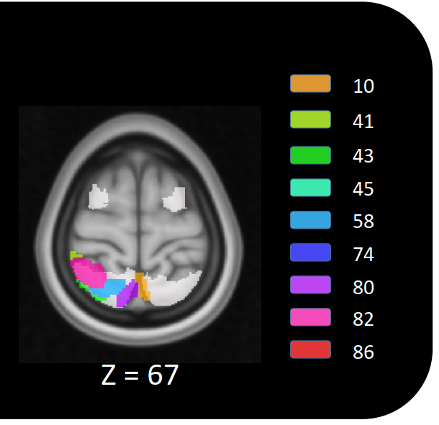
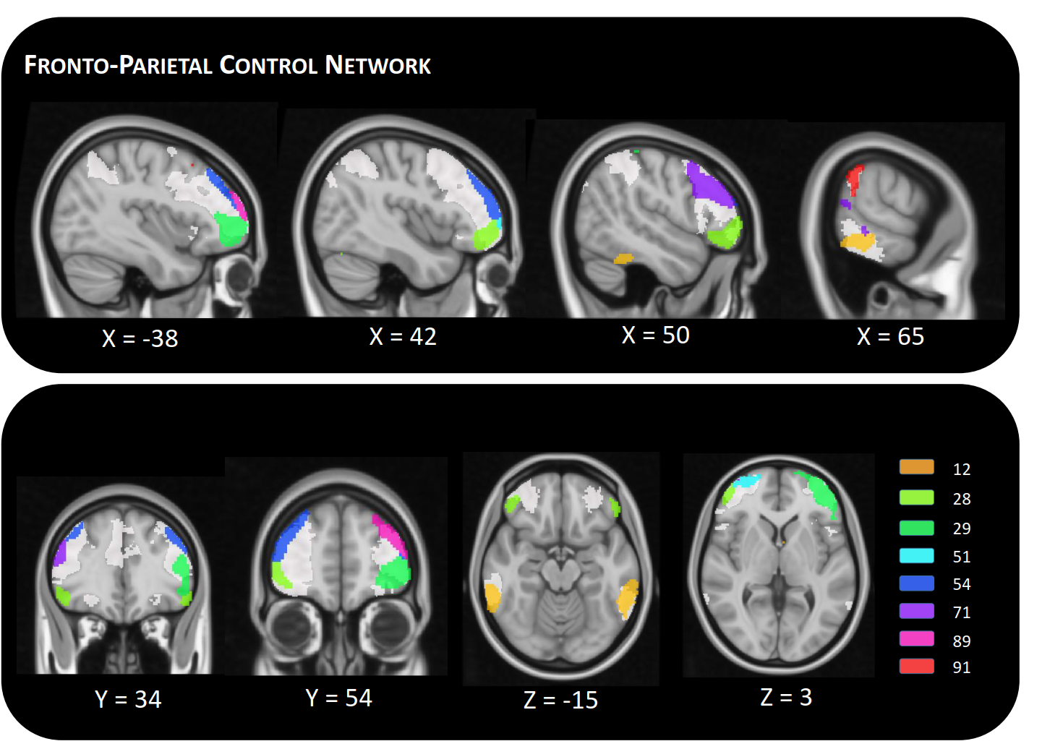
Supplementary Fig. 1: Included independent components in MNI space. Maps show the 39 identified signal components sorted into seven intrinsic functional connectivity networks according to ¹, which are displayed transparent. Each color corresponds to a different component. For visualization purposes, maps show only the 60% highest values of components values. Component labels and peak coordinates are provided in Supplementary Table 2.

Supplementary Fig. 2: Visualization of elbow criterion.

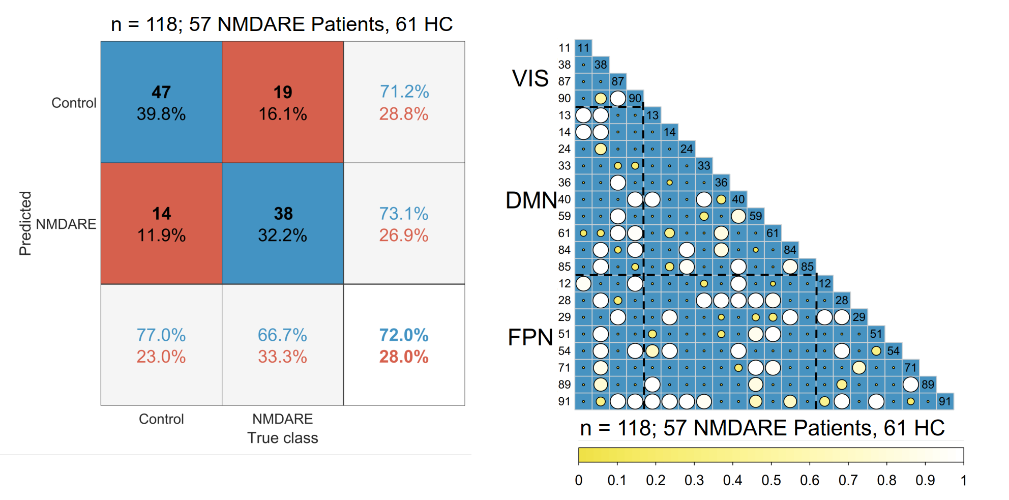
Supplementary Fig. 3: Confusion plot and feature selection matrix for static FC. Feature selection matrices showing all features that were selected for classification in at least 10% (threshold ≥ 0.1) of the classification after hyperparameter optimization (L1 regularization). Bigger and brighter circles indicate a higher selection rate (in percent/100) for classification. A key for the region numbers is provided in Supplementary Table 2. VIS = visual network; DMN = default mode network; FPN = fronto-parietal network; NMDARE = anti-NMDA receptor encephalitis; HC = healthy controls.

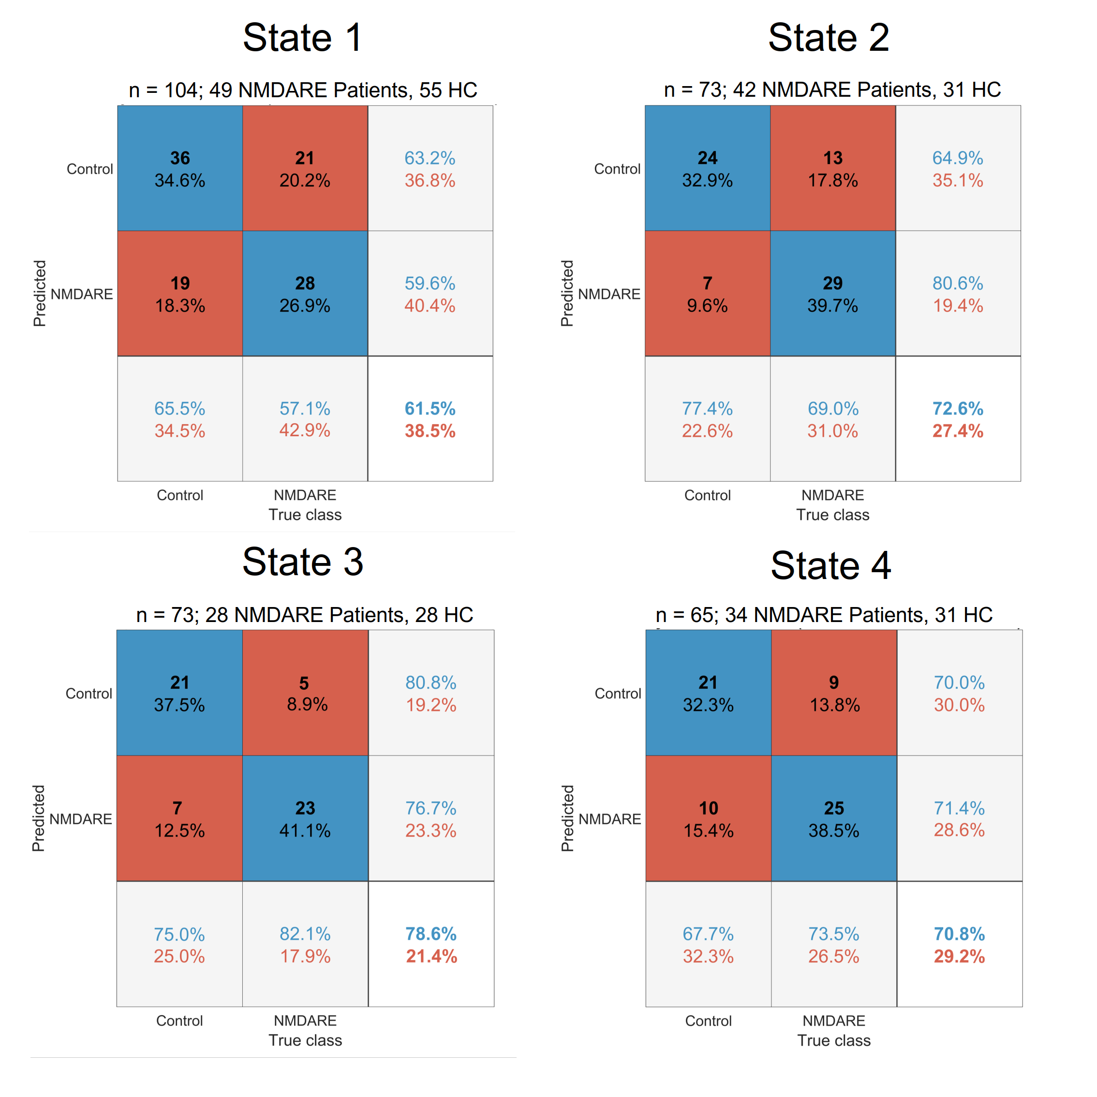
Supplementary Fig. 4: Standard confusion matrix for each state. Matrices indicate classification performance (i.e., true and false positive and negative rates and overall accuracy). NMDARE = NMDARE = anti-NMDA receptor encephalitis; HC = healthy controls.

References

1. Thomas Yeo BT, Krienen FM, Sepulcre J, et al. The organization of the human cerebral cortex estimated by intrinsic functional connectivity. J Neurophysiol. 2011;106(3):1125-1165. doi:10.1152/jn.00338.2011

