Supplementary Tables

Subcortical volumes as early predictors of fatigue in multiple sclerosis
Running title: Early MRI predictors of fatigue

Fleischer et al.

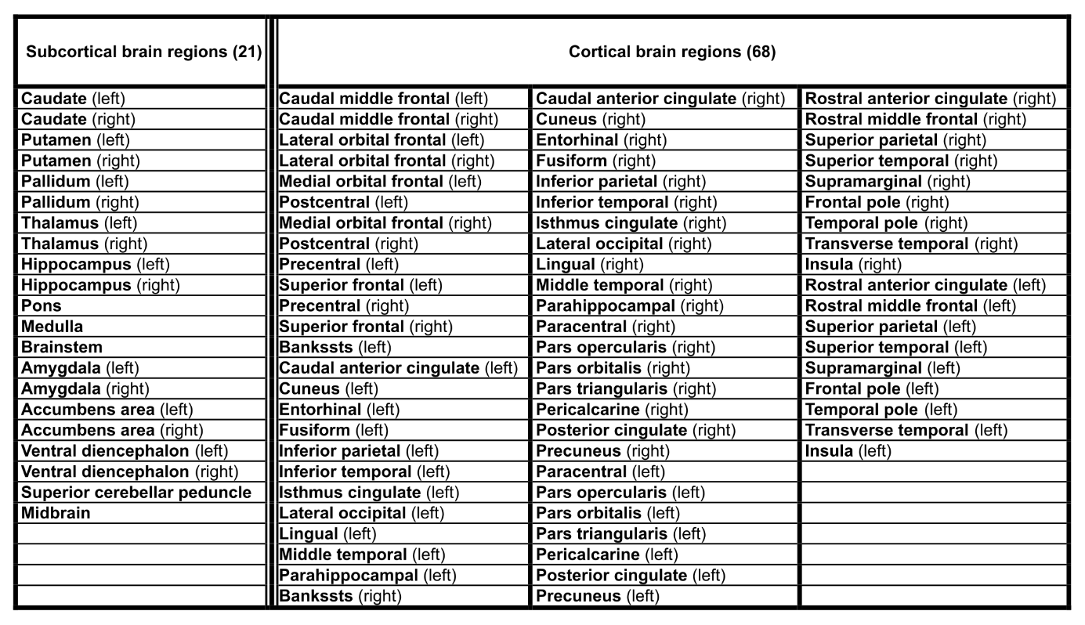
Table S1. List of subcortical and cortical brain regions. In total, 21 subcortical brain regions and 68 cortical brain regions were included in the SEM analysis and in the structural covariance network analysis.

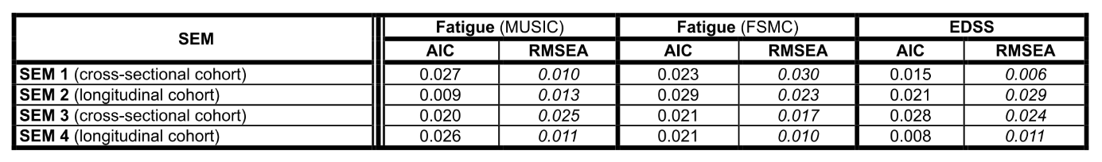
Table S2. Akaike Information Criterion (AIC) and Root Mean Square Error of Approximation (RMSEA). The AIC and RMSEA are given for all SEM models, each in the cross-sectional and longitudinal approach.

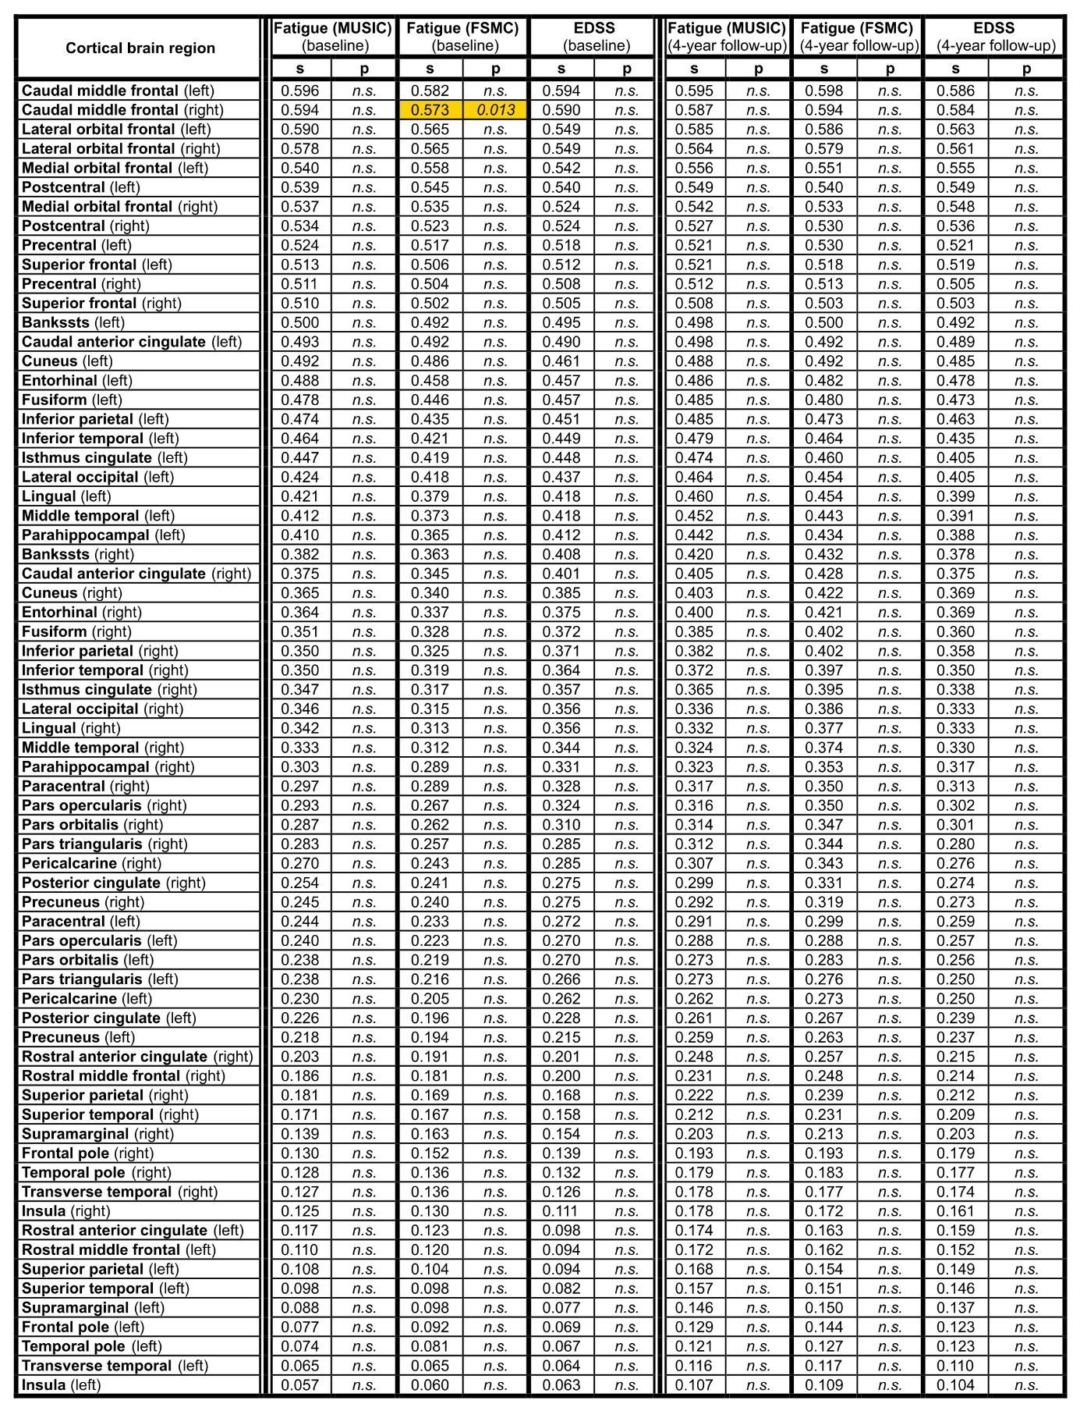
Table S3: Cortical brain regions: Structural equation modeling (SEM) results of the cross-sectional (n=601) and longitudinal (n=230) MS cohort. Association between 68 cortical brain volumes and fatigue (subscale of MUSIC and FSMC) and EDSS scores at baseline and at 4-year follow-up. Significant associations are colored in the table (standardized coefficient = s).
.

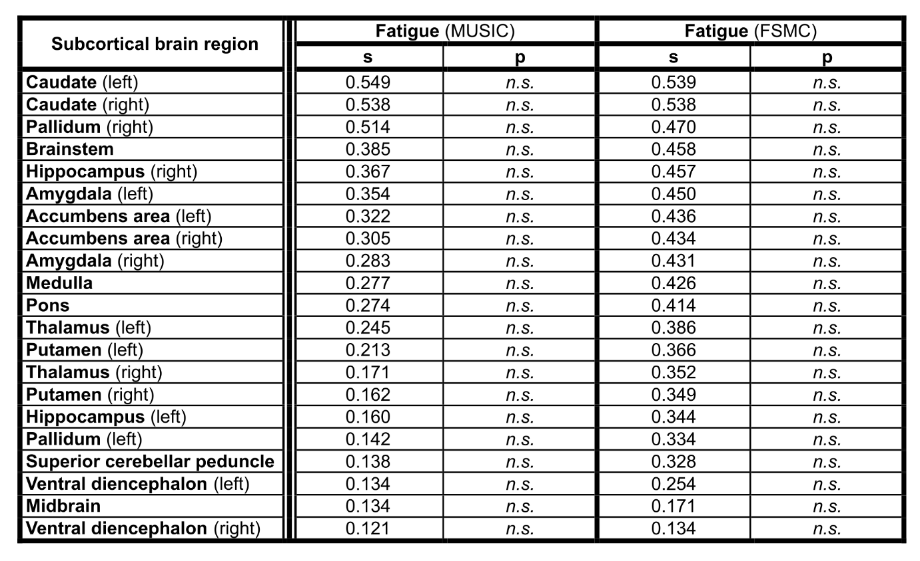
Table S4. Subcortical structural equation modeling (SEM) results of the healthy control cohort (n=89). Association between 21 subcortical brain volumes and fatigue (subscale of MUSIC and FSMC) at the time point of MRI (standardized coefficient = s).

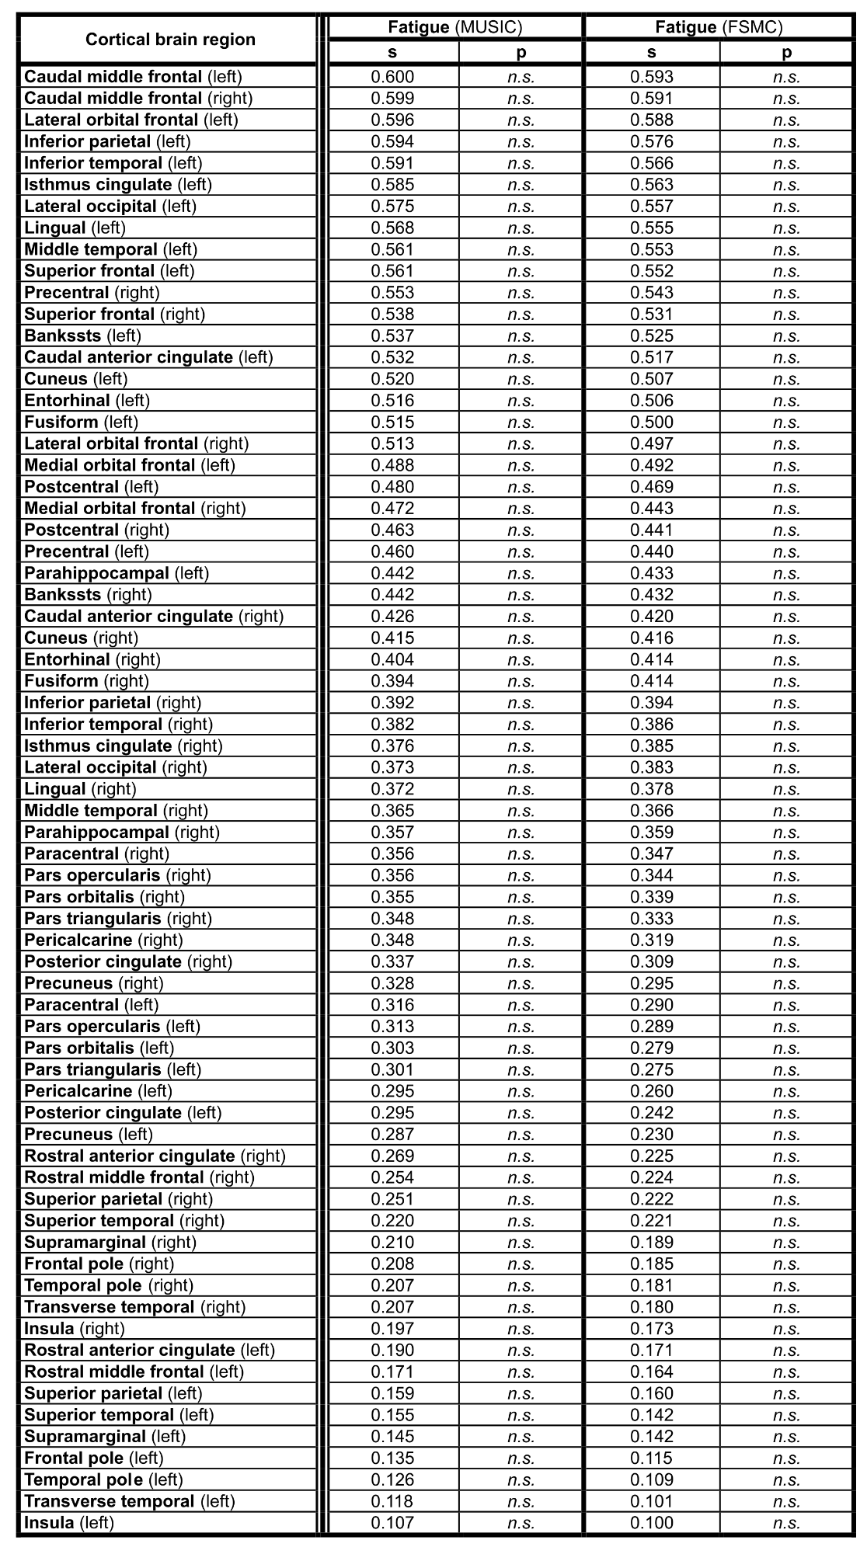
Table S5. Cortical structural equation modeling (SEM) results of the healthy control cohort (n=89). Association between 68 cortical brain volumes and fatigue (subscale of MUSIC and FSMC) at the time point of MRI (standardized coefficient = s).

