Supplementary Information

A deletion containing a CTCF-element in intron 8 of the Bbs7 gene is partially responsible for juvenile obesity in the Berlin Fat Mouse

Mammalian Genome

Florian Krause ^{1,*}, Kourosh Mohebian ^{1,*}, Manuel Delpero ¹, Deike Hesse ¹, Ralf Kühn ², Danny Arends ¹, Gudrun A. Brockmann ^{1,†}
¹ Albrecht Daniel Thaer-Institut für Agrar- und Gartenbauwissenschaften, Humboldt-Universität zu Berlin, Invalidenstraße 42, D-10115 Berlin, Germany
² Max-Delbrück-Center for Molecular Medicine in the Helmholtz Association, Robert-Rössle-Str. 10, D-13125 Berlin, Germany
* First two authors contributed equally
† Corresponding author
Address for correspondence:
Gudrun A. Brockmann
Animal Breeding Biology and Molecular Genetics
Humboldt-Universität zu Berlin,
Invalidenstraße 42,
D-10115 Berlin, Germany
Phone: 0049 30 2093 49872
Fax: 0049 30 2093 6397
E-mail: gudrun.brockmann@agrar.hu-berlin.de

Table 1: Animals (males/females) in each generation
Generation | Family 1 (I8Δ1) |  | Family 2 (I8Δ2)
 | males | females | males | females
7 | 44 | 44 | 20 | 23
8 | 40 | 42 | 9 | 9
9 | 41 | 38 | 26 | 30
10 | 41 | 26 | 27 | 21
11 | 27 | 32 | 36 | 30
12 | 29 | 29 | 37 | 25
13 | 38 | 28 | 25 | 20
14 | 23 | 19 | 42 | 28

Table 2: Designed primers for genotyping
Deletion | Primer | Primer sequence
I8Δ1
 | 1st Fwd | GACACTGAGGAAAACCTGAATGA
 | 2nd Fwd | AGCCAGACAAAGTACACATGA
 | rev | GCCCTTTGAAACCTGTGCTA
I8Δ2
 | 1st Fwd | GACACTGAGGAAAACCTGAATGA
 | 2nd Fwd | CCAAAGCCACACTGACTGTC
 | rev | GCCCTTTGAAACCT TGCTA

Table 3: Means, SDs, and P-values of Family 1 (I8Δ1) for the adjusted fat-to-lean ratio at week 10 of age
 | Mean (SD) | I8∆1/BFMI | I8∆1/I8∆1 | I8∆1/B6N | BFMI/B6N | B6N/B6N
BFMI/BFMI | 0.268 (0.102) | 4.51x10⁻⁹ | 4.85x10⁻⁹ | 1.11x10⁻¹⁰ | 3.81x10⁻¹⁰ | 7.37x10⁻⁷
I8∆1/BFMI | 0.121 (0.047) |  | 0.971 | 0.001 | 0.142 | 0.646
I8∆1/I8∆1 | 0.121 (0.047) |  |  | 0.121 | 0.121 | 0.637
I8∆1/B6N | 0.097 (0.035) |  |  |  | 0.148 | 0.404
BFMI/B6N | 0.110 (0.034) |  |  |  |  | 0.879
B6N/B6N | 0.112 (0.048)
y/I8∆1 | 0.122 (0.047)
x/B6N | 0.096 (0.035)
 | y/I8∆1 | x/B6N
BFMI/BFMI | 3.62x10⁻⁹ | 4.45x10⁻¹¹
y/I8∆1 |  | 4.25x10⁻⁷

Table 4: Means, SDs, and P-values of Family 2 (I8Δ2) for the adjusted fat-to-lean ratio at week 10 of age
 | Mean (SD) | I8∆2/BFMI | I8∆2/I8∆2 | I8∆2/B6N | BFMI/B6N | B6N/B6N
BFMI/BFMI | 0.204 (0.112) | 3.60x10⁻⁶ | 7.42x10⁻⁶ | 3.97x10⁻⁷ | 5.53x10⁻⁷ | 2.48x10⁻⁷
I8∆2/BFMI | 0.088 (0.031) |  | 0.146 | 0.006 | 0.148 | 0.043
I8∆2/I8∆2 | 0.093 (0.032) |  |  | 0.020 | 0.020 | 0.011
I8∆2/B6N | 0.071 (0.028) |  |  |  | 0.336 | 0.953
BFMI/B6N | 0.079 (0.030) |  |  |  |  | 0.428
B6N/B6N | 0.072 (0.018)
y/I8∆2 | 0.091 (0.032)
x/B6N | 0.074 (0.028)
 | y/I8∆2 | x/B6N
BFMI/BFMI | 5.54x10⁻⁶ | 2.98x10⁻⁷
y/I8∆2 |  | 3.17x10⁻⁵

Supplementary Figure 1: Uncorrected fat-to-lean ratios of Family 1 (I8Δ1) and Family 2 (I8Δ2) separated into males and females for 10-week-old mice. No correction was done for generation and litter size, already in the raw data the complementation group (BFMI/I8Δ*) is showing a higher fat-to-lean ratio compared to the negative control (I8Δ*/B6N).
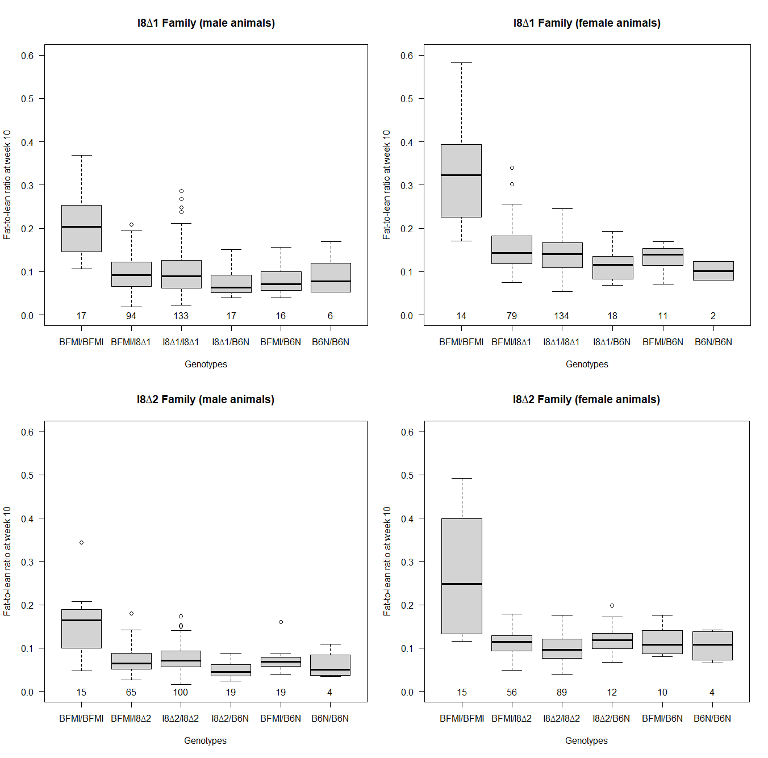

Supplementary Figure 2: Uncorrected Fat and Lean percentages A) fat % of male and female mice from family 1 (I8Δ1). B) lean % of male and female mice from family 1 (I8Δ1). C) fat % of male and female mice from family 2 (I8Δ2). D) lean % of male and female mice from family 2 (I8Δ2).
