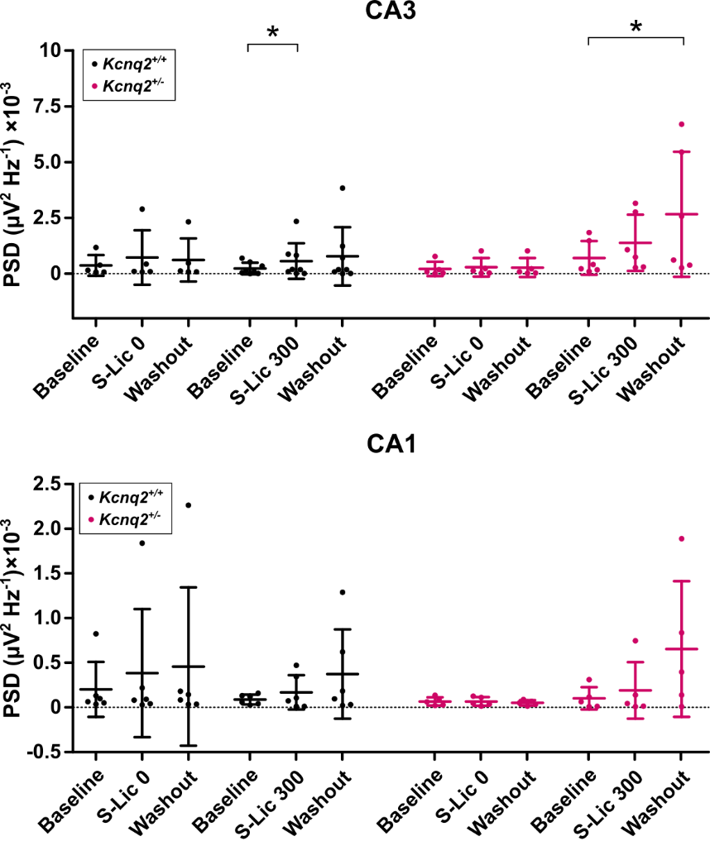

Supplementary figure 1: Analysis of power spectral density of gamma oscillations. Scatter plots showing the power spectral density (PSD) of gamma oscillations recorded from CA3 (upper panel) and CA1 (lower panel), during baseline, upon application of vehicle control (S-Lic 0) or S-Lic 300 µM, respectively, and washout. Each dot refers to one slice obtained from one animal; data are shown as mean ± standard deviation. Asterisks mark statistically significant differences as assessed by one-way ANOVA or Friedman test and Tukey´s or Dunnett´s post hoc test for multiple comparisons, respectively (p-value ≤ 0.05). Kcnq2^{+/+}: S-Lic n = 8, vehicle control n = 5; Kcnq2^{+/-} S-Lic n = 6, vehicle control n = 5.

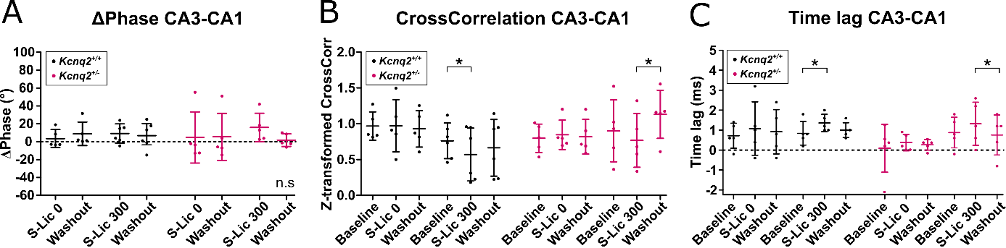

Supplementary figure 2: CA3-CA1 temporal relationship during gamma oscillations. Analysis of S-Lic effects on temporal relationship between CA3 and CA1. (A) Delta phase of gamma oscillations recorded simultaneously from CA3 and CA1, during application of vehicle control or S-Lic, respectively, and washout. n.s.: not significant differences as assessed by Uniform Score test for circular data. Data are shown as median ± interquartile range. (B) Scatter plot showing gamma z-transformed coefficients of cross-correlation between CA3 and CA1 during baseline, application of vehicle control or S-Lic, respectively, and washout. (A, B) Vehicle control (S-Lic 0): Kcnq2^{+/+} n = 5; Kcnq2^{+/-} n = 5. S-Lic 300: Kcnq2^{+/+} n = 6; Kcnq2^{+/-} n = 5. (C) Scatter plot of time lag between CA3 and CA1 during baseline, application of vehicle control or S-Lic, respectively, and washout. Vehicle control (S-Lic 0): Kcnq2^{+/+} n = 5; Kcnq2^{+/-} n = 5. S-Lic 300: Kcnq2^{+/+} n = 5; Kcnq2^{+/-} n = 5. (B,C) Data are shown as mean ± SD. Asterisks mark statistically significant differences as assessed by one-way ANOVA and Tukey´s post hoc test for multiple comparisons, respectively (p-value ≤ 0.05).

