Supplementary Table 1
Pocock-type stopping boundaries for a true dose-limiting toxicity rate of 40% and a 10% desired probability of early stopping in 10 patients

Number of patients, n | 1 | 2 | 3 | 4 | 5 | 6 | 7 | 8 | 9 | 10
Boundary, b_{n} | - | - | - | 4 | 5 | 5 | 6 | 6 | 7 | 7

Supplementary Figure 1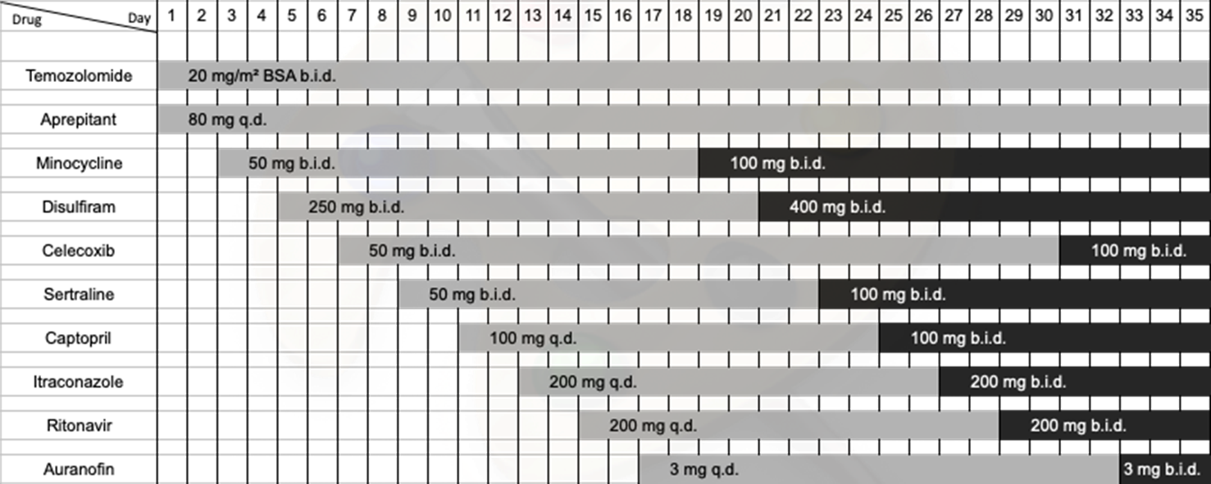
Progressive addition schedule of the CUSP9v3 drugs

BSA: body surface area; b.i.d.: twice a day; q.d.: once a day.

