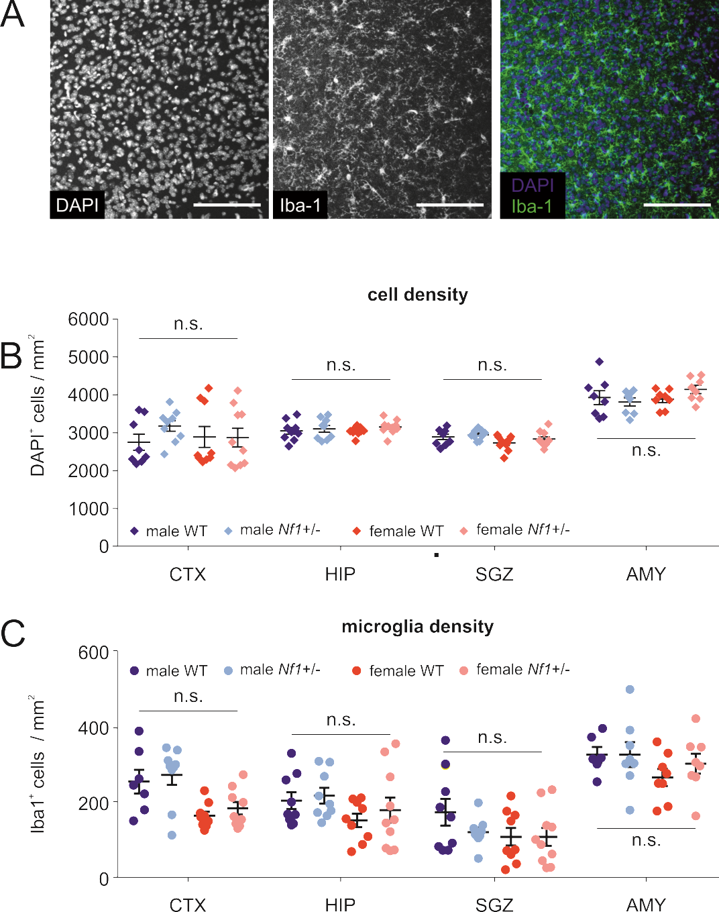

**Supplementary Figure 1.** Cell and microglial density in different brain regions of male and female WT and *Nf1+/-* mice

**A.** Cortical DAPI and Iba1 staining from a representative male WT mouse brain.

**B** and **C.** Total cell (**B**) and microglial (**C)** density values obtained from brain slices of 12-16-week-old male and female WT and *Nf1+/-* mice. The following brain regions were analyzed: medial prefrontal cortex (CTX), hippocampal CA2-CA3 regions (HIP), subgranular zone (SGZ), and amygdala (AMY). N=9-10 animals per condition were analyzed. Two way ANOVA followed by Bonferroni post hoc tests were performed, which revealed no significant differences in cell numbers between the four groups (male and female WT and *Nf1+/-* mice).

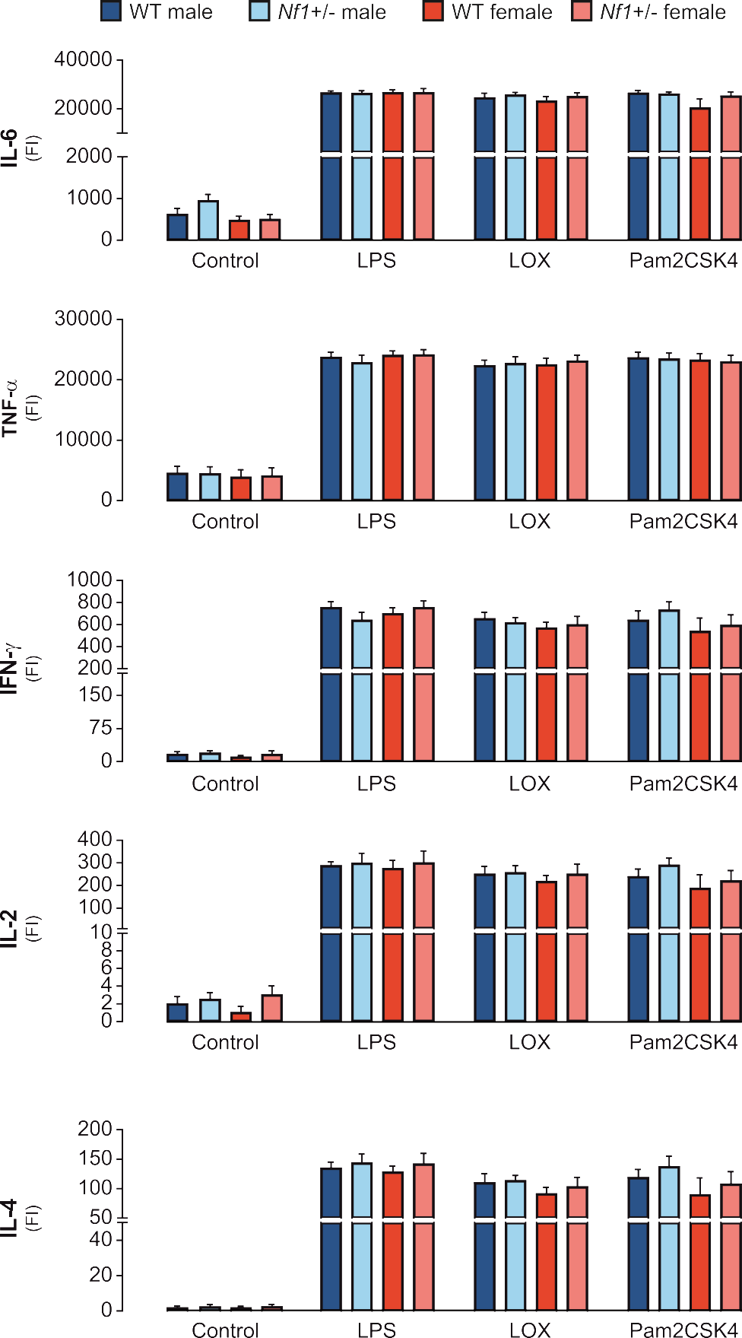

**Supplementary Figure 2.** Adult cultured microglia derived from *Nf1+/-* and WT male and female mice do not differ in terms of cytokine release following TLR activation.

Adult microglia cultures were stimulated with LPS (100ng/ml), LOX (1mM) or Pam2CSK4 (100ng/ml) for 24 hours. Supernatants were collected, and Multiplex ELISA was performed to analyze microglial release of IL-6, TNF-α, IFN-γ, IL-2 and IL-4. Data are shown as the mean Fluorescent Intensity (FI). Unstimulated cells were used as controls. N=5 independent microglia cultures were used per condition. One way ANOVA followed by Bonferroni post hoc tests revealed no significant differences in cytokine release between male and female WT and *Nf1*+/- microglia.

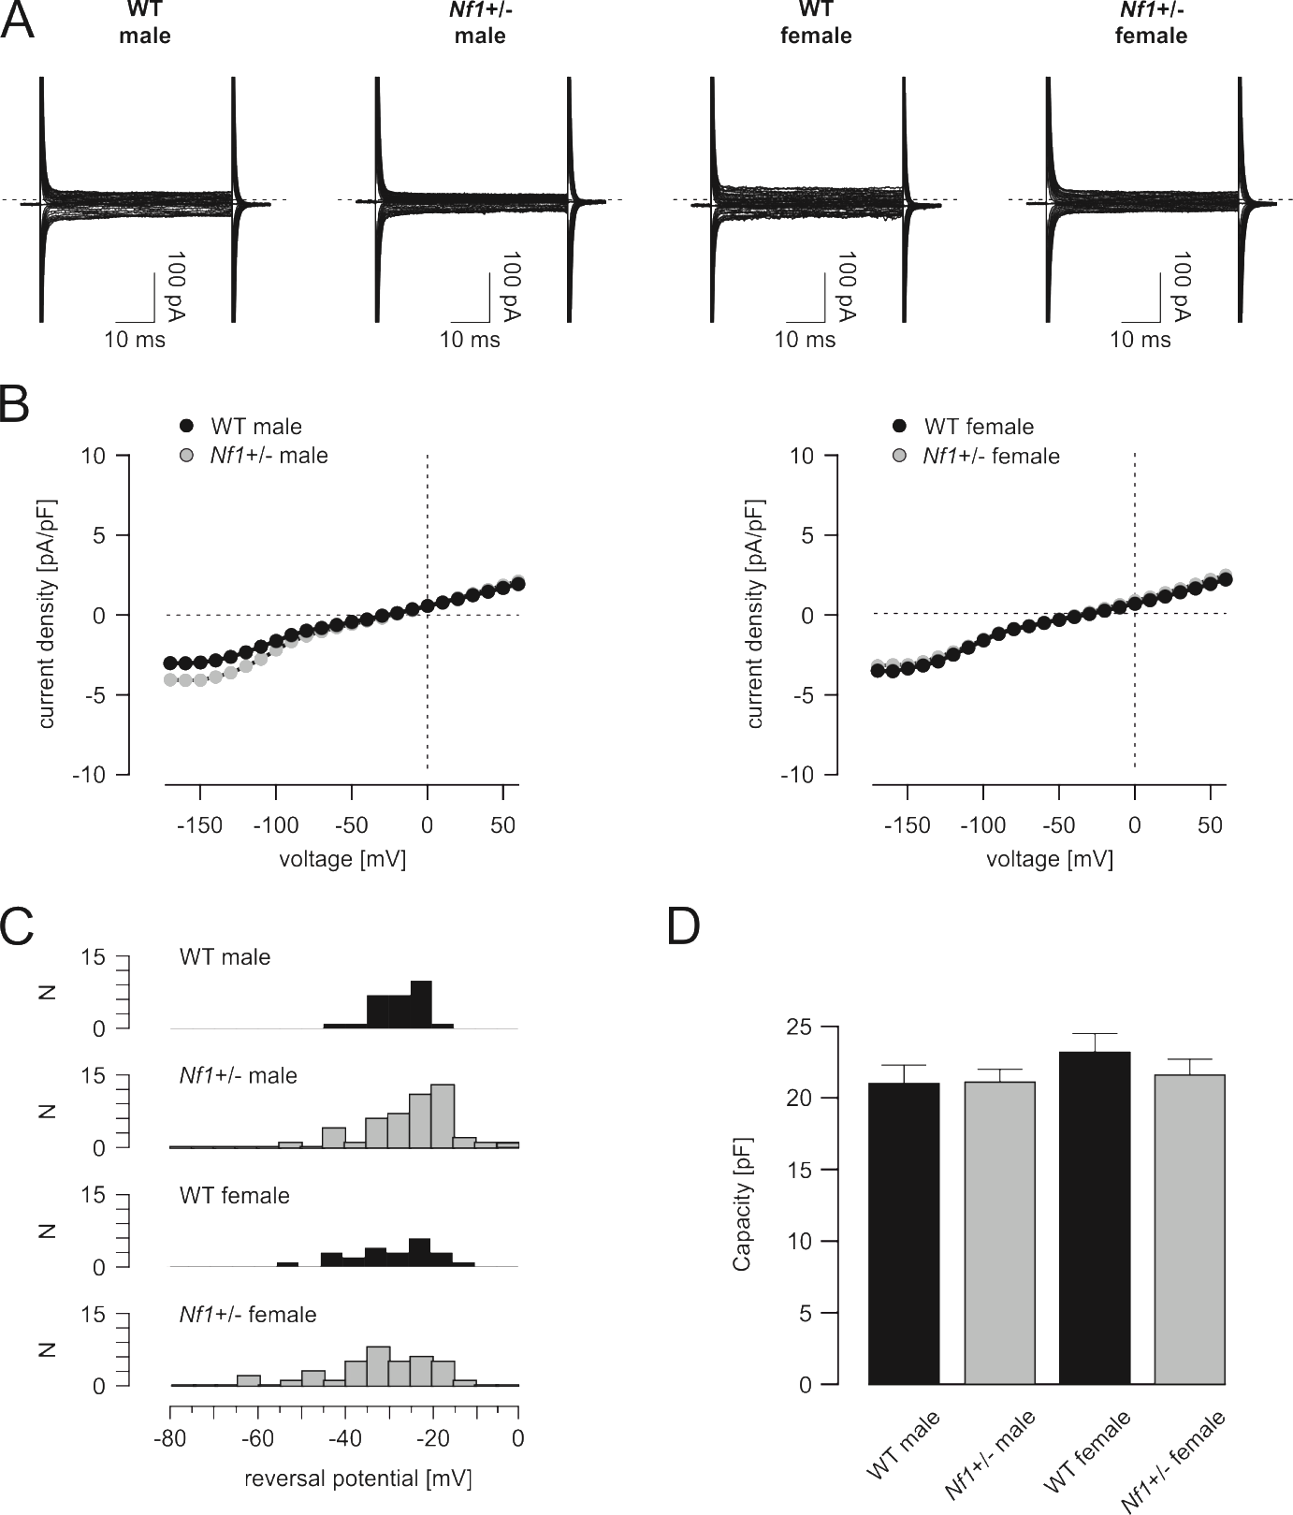

**Supplementary Figure 3.** Membrane properties of *Nf1+/-* microglia are similar to WT microglia

**A:** Sample currents of microglia from 12-16 week old WT and *Nf1+/-* mice, which were obtained during a series of voltage pulses ranging from ‑170 to +60 mV, with 10 mV increments from a holding potential of ‑70 mV.

**B:** Summarized and averaged current-voltage relationships from 12-16 week old WT and *Nf1+/-* microglia. Currents were normalized to the membrane capacitance before averaging. See panel A for sample traces. There were no significant sex- or *Nf1*-dependent differences (ANOVA/Tukey).

**C**: Distribution of the reversal potentials (indicative of the membrane potential), shown as averaged histograms of all recorded microglial cells from male and female WT and *Nf1+/-* mice.

**D**: Summary of the membrane capacitances of microglia from WT and *Nf1+/-* mice. There were no significant sex- or *Nf1*-dependent differences (ANOVA/Tukey).

Number of recorded cells (mice): male WT, 32 (13); male *Nf1+/-*, 42 (18); female WT, 23 (13); female *Nf1*+/-, 37 (17).

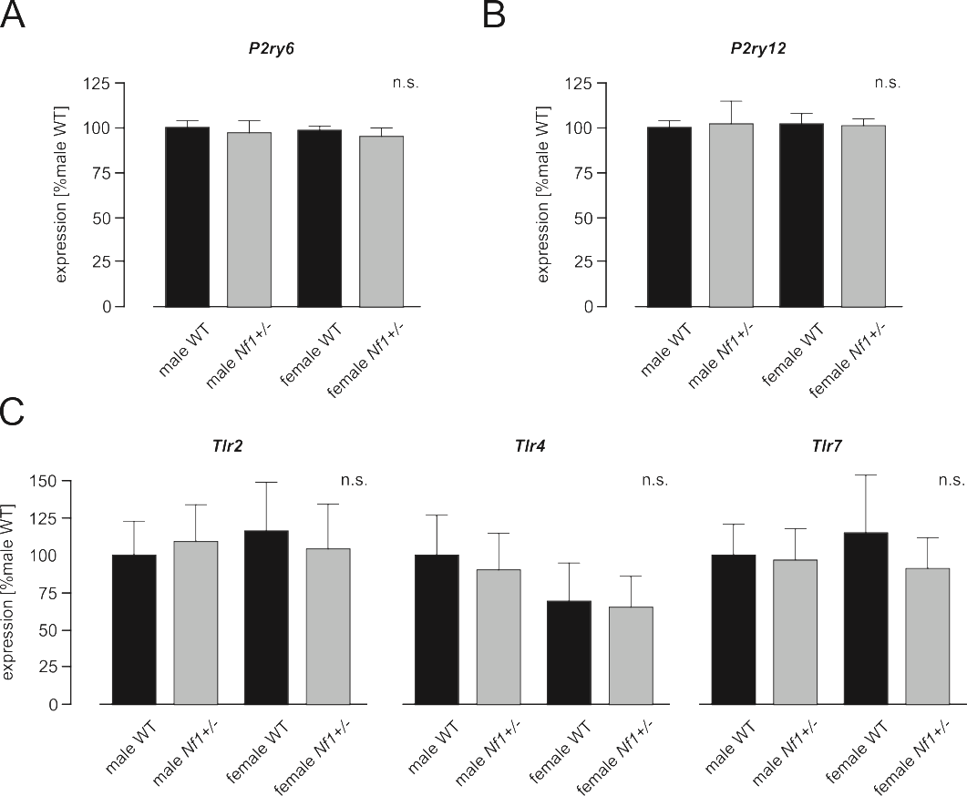

**Supplementary Figure 4.** Expression of purinergic or Toll-like receptors is not sexually dimorphic or influenced by *Nf1* mutation

**A** - **C:** qPCR on cDNA from male and female WT and *Nf1+/-* microglia revealed no changes in *P2ry6* (**A**), *P2ry6* (**B**) or *Tlr2*, *Tlr4*, and *Tlr7* (**C**) mRNA expression.

N = 4-5 mice were used per condition. One way ANOVA followed by Tukey post hoc tests revealed no significant differences in mRNA expression between male and female WT and *Nf1*+/- microglia (A-C).

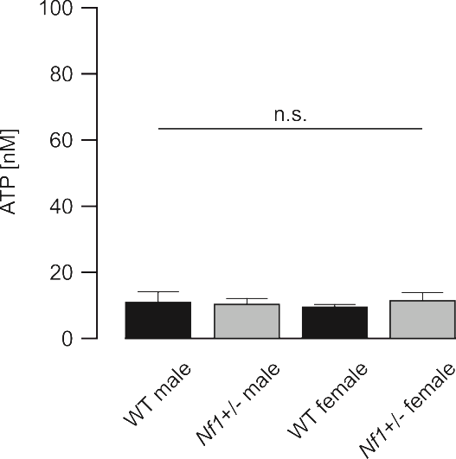

**Supplementary Figure 5.** Viability of MACS-isolated microglia is not sexually dimorphic or influenced by *Nf1* mutation

Viability was tested using a commercial assay (see Materials and Methods section) based on determining the intracellular ATP content as a measure of cell metabolism. Male and female WT and *Nf1*+/- microglia displayed similar intracellular ATP levels indicative of similar viability following the MACS isolation procedure.

N = 3 mice were used per condition. One way ANOVA followed by Tukey post hoc tests revealed no significant differences in the cell viability of MACS-isolated microglia from male and female WT and *Nf1*+/- mice.