SUPPLEMENTAL INFORMATION

Targeted panel sequencing in pediatric primary cardiomyopathy supports a critical role of TNNI3

Jirko Kühnisch^{1,2}*, Christopher Herbst^{1,2,3}*, Nadya Al-Wakeel-Marquard^{2,3,4}, Josephine Dartsch¹, Manuel Holtgrewe^{5,6}, Anwar Baban⁷, Giulia Mearini^{8,9}, Juliane Hardt^{10,11}, Konstantinos Kolokotronis¹², Brenda Gerull¹³, Lucie Carrier^{8,9}, Dieter Beule^{5,14}, Stephan Schubert^{2,3}, Daniel Messroghli^{2,15,16}, Franziska Degener^{2,3,4}, Felix Berger^{2,3,17}, Sabine Klaassen^{1,2,17}

* These authors contributed equally to the work

Correspondence to:

Sabine Klaassen, MD
Experimental and Clinical Research Center (ECRC),
a joint cooperation between the Charité Medical Faculty
and the Max Delbrück Center for Molecular Medicine (MDC),
Lindenberger Weg 80, 13125 Berlin, Germany
Phone: +4930 9406-3319, Fax: +49 30 9406-3358,
Email: klaassen@mdc-berlin.de

SUPPLEMENTAL FIGURES S1-S6

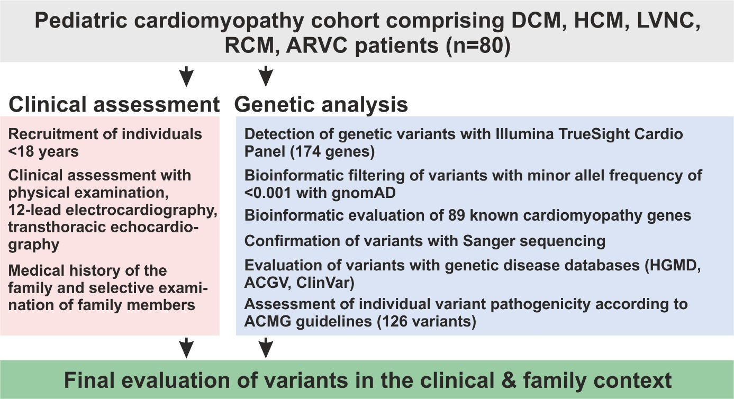

Figure S1. Flow chart of study design and genetic evaluation approach.
Patients of the cohort were classified for cardiomyopathy (DCM, HCM, LVNC, RCM, and ARVC) after cardiological assessment. DNA samples of index patients were genetically investigated with a NGS CardioPanel approach. Accumulated clinical and genetic information was used for final assessment of detected variants. For interpretation of sequence variants according to ACMG criteria a frequency threshold of <0.0001 was applied.

Abbreviations: hypertrophic cardiomyopathy (HCM), dilated cardiomyopathy (DCM), restrictive cardiomyopathy (RCM), left ventricular noncompaction cardiomyopathy (LVNC), arrhythmogenic right ventricular cardiomyopathy (ARVC), Genome Aggregation Database (gnomAD), human gene mutation database (HGMD), atlas of cardiac genetic variation (ACGV), National Center for Biotechnology (NCBI) database ClinVar, American College of Medical Genetics (ACMG) guidelines

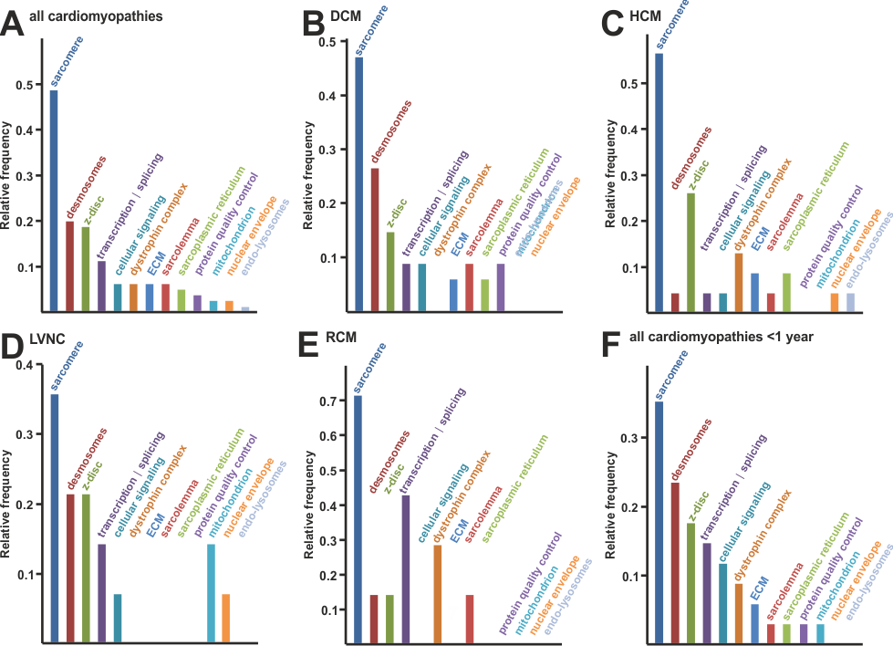

Figure S2. Relative frequency of patients per functional group.
A, Detected variants were classified according to molecular functional groups (see Table S1). The relative frequency of patients with VOI per functional group is plotted for the entire cohort. B-E, The relative frequency of patients with VOI per functional group for CMP subtypes DCM, HCM, LVNC, and RCM. F, The relative frequency of patients with VOI per functional group shown for patients with diagnosis of CMP <1 year of age.

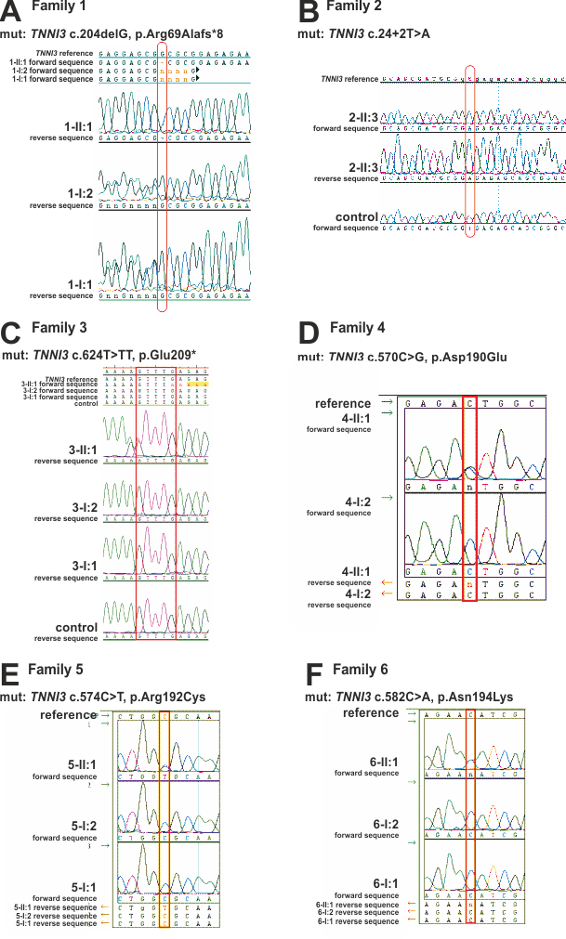
Figure S3. Molecular genetic analysis of families with hetero- or homozygous TNNI3 variants.
A-F, Molecular genetic confirmation of TNNI3 variants in family 1-6 with Sanger sequencing in the index patient and first degree family members, if available. The genetic alteration is highlighted with a red box.

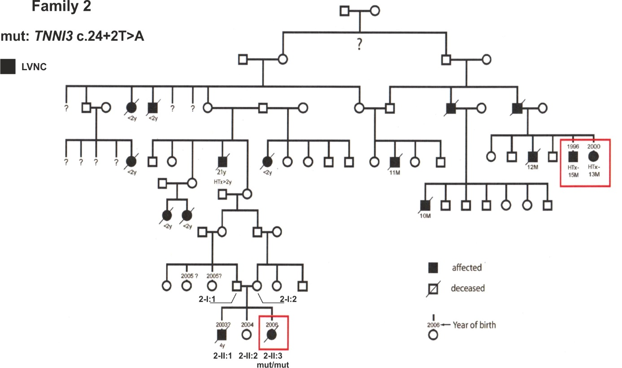

Figure S4. Extended pedigree of family 2.
A, The complete pedigree of family 2 shows consanguineous marriage of individual 2-I:1 and 2-I:2. Throughout previous generations 14 individuals in total developed early onset CMP leading to childhood death or HTX. None of the other affected or unaffected family members were available for detailed clinical assessment or genetic testing.

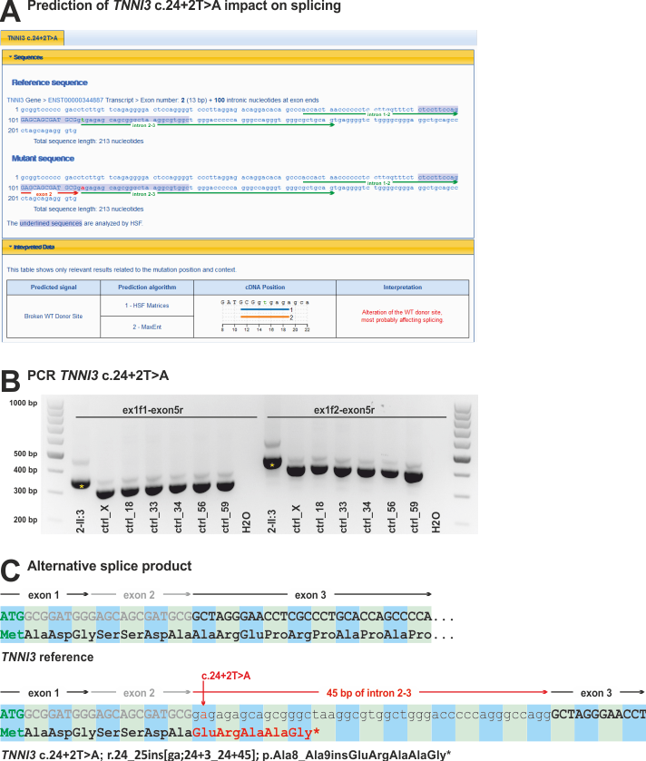

Figure S5. Molecular analysis of the splice site variant TNNI3 c.24+2T>A.
A, Analysis of the TNNI3 variant c.24+2T>A with Human Splicing Finder (www.umd.be/HSF3) predicts a negative effect of this variant. B, The endpoint PCRs ex1f1-exon5r and ex1f2-exon5r were established on cDNA isolated from heart tissue of the patient and controls. Patient 2-II:3 shows for both PCRs an increased fragment size of approx. 50 bp (yellow star) compared to controls. C, Sanger sequencing identified an insertion of 45 bp between exon 2 and exon 3. On protein level, this inserts five amino acids GluArgAlaAlaGly* (TNNI3 p.Ala8_Ala9insGluArgAlaAlaGly*) before a stop codon terminates translation.

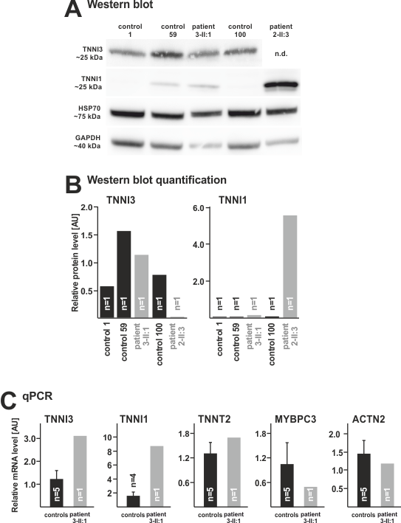
Figure S6. Functional analysis of a heart biopsy from individual 3-II:1 with the heterozygous TNNI3 variant c.624T>TT, p.Glu209*.
A, Western blot reveals expression of TNNI3 protein in the 3-II:1 patient heart biopsy and no upregulation of TNNI1 protein. B, Quantification of protein levels confirms normal TNNI3 expression in the 3-II:1 patient. TNNI1 protein level did not change in the 3-II:1 heart biopsy but was markedly higher in patient 2-II:3 (homozygous splice site variant TNNI3 c.24+2T>A). TNNI3 values were adapted from Fig.4C-D. C, Quantitative PCR (qPCR) identifies transcriptional upregulation of TNNI3 and TNNI1. The transcript of MYBPC3 is mildly reduced.

Supplemental Tables S1-S5

Table S1: Primers used in this study
Gene | Transcript | Primer | Primer sequence | Length (nucleotides)
Primer for genomic exon amplification
TNNI3 | NM_000363.4 | ghTNNI3_ex2_f | aagtgggtttgcgagtca | 18
 |  | ghTNNI3_ex2_r | ccatcaccaccaagaccc | 18
 |  | ghTNNI3_ex5_f | ggagcttgagaatgggtggg | 20
 |  | ghTNNI3_ex5_r | gagccaagactccacagacc | 20
 |  | ghTNNI3_ex8_f(a) | agatacttaggcatccagggtag | 23
 |  | ghTNNI3_ex8_r(a) | acagccaagagtgcttcacat | 21
 |  | ghTNNI3_ex8_f(b) | gctactattgacctgagaatcc | 22
 |  | ghTNNI3_ex8_r(b) | acagccaagagtgcttcacat | 21
Primer for cDNA exon amplification for splice site analysis TNNI3 c.24+2T>A
TNNI3 | NM_000363.4 | chTNNI3_ex1_f1 | TCACTGACCCTCCAAACG | 18
 |  | chTNNI3_ex1_f2 | GGGAGTCTCAAGCAGCCC | 18
 |  | chTNNI3_ex5_r | TGGCAGCGGGTGCTCAGA | 18
Primer for cDNA amplification with quantitative PCR
TNNI1 | NM_003281 | qhTNNI1_ex5-6_f | GGATGAGGAGCGATACGACA | 20
 |  | qhTNNI1_ex5-6_r | GGCGCTTGAACTTCCCAC | 18
TNNI3 | NM_000363.4 | qhTNNI3_ex3-4_f | CACCAGCCCCAATCAGACG | 19
 |  | qhTNNI3_ex3-4_r | CTGCAATTTTCTCGAGGCGG | 20
TNNT2 | NM_000364 | qhTNNT2_ex14-15_f | GAGCTGTGGCAGAGCATCTA | 20
 |  | qhTNNT2_ex14-15_r | ATCCTGTTTCGGAGAACATTG | 21
MYBPC3 | NM_000256 | qhMYBPC3_ex11-12_f | GCATGAGGCGCGATGAGAAGA | 21
 |  | qhMYBPC3_ex11-12_r | CAGCCAGTTCCACGGTCAGC | 20
ACTN2 | NM_001278343 | qhACTN2_ex13-14_f | TTGGAACACCTGGCTGAGA | 19
 |  | qhACTN2_ex13-14_r | GCCGACTCGTAATCCTTCTG | 20
Table S2: Functional classification and description of analyzed genes

Functional classification | Gene name | Gen | Protein | Chromo-  some | Transcript ID | Exons | Function
Sarcoplasmic reticulum | calreticulin 3 | CALR3 | CALR3 | Chr19 | ENST00000269881.7  NM_145046 | 9 | Ca²⁺ binding protein within SR
 | dolichol kinase | DOLK | DOLK | Chr9 | ENST00000372586.3 NM_014908 | 1 | dolichol kinase within SR; involved in GPI-anchor, N- and O-linked protein glycosylation
 | phospholamban | PLN | PLN | Chr6 | ENST00000357525.5 NM_002667 | 2 | regulation of cardiac ATP2A2 Ca²⁺ ATPase, critical regulator Ca²⁺ homeostasis
 | ryanodine receptor 2 | RYR2 | RYR2 | Chr1 | ENST00000366574.6 NM_001035.2 | 105 | Ca²⁺ channel releasing Ca²⁺ from SR into cytoplasm, regulation of cardiomyocyte contractility
Sarcolemma | ATP binding cassette subfamily C member 9 | ABCC9 | ABCC9 | Chr12 | ENST00000261200.8  NM_020297  ENST00000261201.8 NM_005691 | 38 | regulation of KCNJ11 potassium channel
 | caveolin 3 | CAV3 | CAV3 | Chr3 | ENST00000343849.2 NM_033337 | 2 | scaffolding protein of caveolae, regulation of G-protein alpha subunits and potassium channels, sarcolemma repair
 | hyperpolarization activated cyclic nucleotide gated potassium channel 4 | HCN4 | HCN4 | Chr15 | ENST00000261917.3 NM_005477.2 | 8 | hyperpolarization-activated ion channel with slow activation and inactivation, exhibiting weak selectivity for potassium over sodium ions, cAMP regulated
 | hemochromatosis | HFE | HFE | Chr6 | ENST00000357618.9  NM_000410.3 | 5 | transferrin receptor binding, regulation endocytosis of iron loaded transferrin
 | junctophilin-2 | JPH2 | JPH2 | Chr20 | ENST00000372980.3 NM_020433.4 | 6 | formation of junctional membrane complexes between plasma membrane and SR, regulator of Ca²⁺ signaling
 | sodium channel protein type 5 subunit alpha | SCN5A | SCN5A | Chr3 | ENST00000413689.5  NM_001099404.1 | 28 | mediates voltage-dependent Na+ permeability of excitable membranes
Z-disc | actinin alpha 2 | ACTN2 | ACTN2 | Chr1 | ENST00000366578.5  NM_001103.2 | 21 | F-actin crosslinking protein
 | ankyrin repeat domain 1 | ANKRD1 | ANKRD1 | Chr10 | ENST00000371697.3 NM_014391.2 | 9 | myofibrillar stretch-sensor z-disk, transcription factor that negatively regulates cardiac gene expression
 | cysteine and glycine rich protein 3 | CSRP3 | CSRP3 | Chr11 | ENST00000533783.1 NM_003476 | 7 | scaffolding protein at z-disc, actin binding, regulation of actin dynamics myogenic transcriptional cofactor
 | four and a half LIM domains 1 | FHL1 | FHL1 | ChrX | ENST00000394155.6 NM_001159702.2 | 8 | mechanosensor at z-disc, transcriptional cofactor
 | four and a half LIM domains 2 | FHL2 | FHL2 | Chr2 | ENST00000344213.8 NM_201555.1 | 7 | mechanosensor at z-disc, transcriptional cofactor
 | LIM domain binding 3 | LDB3 | LDB3 | Chr10 | ENST00000429277.6 NM_001171610.1 | 14 | Interaction with actin, stabilization sarcomere during contraction
 | myozenin 2 | MYOZ2 | MYOZ2 | Chr4 | ENST00000307128.5 NM_016599.4 | 6 | z-disc organization by interaction with several proteins, myofibrillogenesis, calcineurin signaling
 | myopalladin | MYPN | MYPN | Chr10 | ENST00000358913.9 NM_032578 | 20 | scaffold at z-disc; binds nebulette, nebulin, α-actinin
 | nexilin F-actin binding protein | NEXN | Taz  N | Chr1 | ENST00000334785.11 NM_144573.3 | 13 | F-actin binding, maintenance z-disc and sarcomere integrity
 | PDZ and LIM domain 3 | PDLIM3 | PDLIM3 | Chr4 | ENST00000284770.9 NM_014476 | 7 | crosslinking of F-actin with α-actinin-2
 | titin-cap, telethonin | TCAP | TCAP | Chr17 | ENST00000309889.2 NM_003673 | 2 | binds titin at z-disc, part of mechanosensing system, important for interaction of z-disc and T-tubules
 | vinculin | VCL | VCL | Chr10 | ENST00000211998.9 NM_014000.2 | 22 | F-actin binding, mechanosensing, cell-matrix and cell-cell adhesion, linker of z-disc proteins to catenin cadherin dystroglycan
Sarcomere thick filament | myosin binding protein C, cardiac | MYBPC3 | MYBPC3 | Chr11 | ENST00000545968.5 NM_000256.3 | 35 | integrates myosin heavy chain and F-actin, modulation of muscle contraction and sarcomere organization
 | myosin heavy chain 6 | MYH6 | MYH6, MHC-α | Chr14 | ENST00000405093.7 NM_002471.3 | 39 | major component of cardiac muscle thick filament, muscle contraction, fast myosin isoform, ATPase activity
 | myosin heavy chain 7 | MYH7 | MYH7, MHC-β | Chr14 | ENST00000355349.3 NM_000257.2 | 40 | major component of cardiac muscle thick filament, muscle contraction, slow myosin isoform, ATPase activity
 | myosin light chain 2 | MYL2 | MYL2 | Chr12 | ENST00000228841.12 NM_000432.3 | 7 | stabilizes S1 neck region of myosin heavy chain
 | myosin light chain 3 | MYL3 | MYL3 | Chr3 | ENST00000292327.4 NM_000258.2 | 7 | stabilizes S1 neck region of myosin heavy chain
 | myosin light chain kinase 2 | MYLK2 | MYLK2 | Chr20 | ENST00000375985.4 NM_033118.3 | 13 | essential for muscle contraction cycle, phosphorylates specific position of myosin light chain
 | titin | TTN | titin | Chr2 | ENST00000589042.5 NM_001267550.1 | 363 | central sarcomere scaffolding protein required for assembly, protein interaction platform, regulation of sarcomere resting length and passive stiffness
Sarcomere thin filament | actin, alpha 1, skeletal muscle | ACTA1 | ACTA1 | Chr1 | ENST00000366684.7 NM_001100 | 6 | globular G-actin form F-actin fibers; essential part of the contractile apparatus thin filament
 | actin, alpha, cardiac muscle 1 | ACTC1 | ACTC1 | Chr15 | ENST00000290378.4 NM_005159.4 | 7 | globular G-actin form F-actin fibers; essential part of the contractile apparatus thin filament
 | troponin C1, slow skeletal and cardiac type | TNNC1 | TNNC1 | Chr3 | ENST00000232975.7 NM_003280.2 | 6 | binds the switch region of troponin I in a Ca²⁺ dependent manner to activate contraction
 | troponin I3, cardiac type | TNNI3 | TNNI3 | Chr19 | ENST00000344887.9 NM_000363.4 | 8 | inhibitory subunit of troponin, regulation thin filament Ca²⁺ sensitivity
 | troponin T2, cardiac type | TNNT2 | TNNT2 | Chr1 | ENST00000236918.11 NM_001276345 | 16 | binding of troponin complex to tropomyosin
 | tropomyosin 1 | TPM1 | TPM1 | Chr15 | ENST00000403994.7 NM_001018005.1 | 9 | coiled coil protein that lies along thin filament and blocks myosin binding sites on actin under resting calcium concentrations
Nuclear envelope | emerin | EMD | EMD | ChrX | ENST00000369842.8 NM_000117 | 6 | formation and stabilization of cortical nuclear actin network, cellular signaling
 | lamin A/C | LMNA |  | Chr1 | ENST00000368300.8 NM_170707.3 | 12 | nuclear lamina and chromatin organization, critical for nuclear dynamics
 | transmembrane protein 43 | TMEM43 | TMEM43 | Chr3 | ENST00000306077.4 NM_024334.2 | 12 | nuclear envelope structure at inner nuclear membrane, interaction with emerin, mechanotransduction, gene expression
Mitochondria | cytochrome c oxidase assembly homolog | COX15 | COX15 | Chr10 | ENST00000370483.9 NM_001320975 | 9 | heme A biosynthesis, porphyrin synthesis
 | DnaJ heat shock protein family (Hsp40) member C19 | DNAJC19 | DNAJC19 TIM14 | Chr3 | ENST00000382564.6  NM_145261 | 6 | peptide translocation inner membrane to matrix, subunit of HSP40/HSP70 complex, mitochondrial chaperone
 | frataxin | FXN | FXN | Chr9 | ENST00000377270.7  NM_000144 | 5 | heme biosynthesis, protection against iron-catalyzed oxidative stress, iron storage
 | hydroxyacyl-CoA dehydrogenase/3-ketoacyl-CoA thiolase/enoyl-CoA hydratase (trifunctional protein), alpha subunit | HADHA | HADHA | Chr2 | ENST00000380649.7 NM_000182 | 20 | fatty acid beta-oxidation and in lipid metabolism.
 | cytochrome c oxidase assembly protein | SCO2 | SCO2 | Chr22 | ENST00000252785.3  NM_001169111 | 2 | copper chaperone, delivering copper to COX2
 | succinate dehydrogenase complex flavoprotein subunit A | SDHA | SDHA, SDH2 | Chr5 | ENST00000264932.10 NM_004168 | 15 | complex II mitochondrial electron transport chain, transfer of electrons from succinate to ubiquinone, involved tricarboxylic acid cycle
 | tafazzin | TAZ | TAZ | ChrX | ENST00000601016.5 NM_000116 | 11 | synthesis/remodeling of cardiolipin, phospholipid-lysophospholipid transacylase, important for mitochondrial energy production
Desmosome | desmocollin 2 | DSC2 | DSC2 | Chr18 | ENST00000280904.10  NM_024422 | 16 | part of desmosome junctions, cell-cell adhesion, interaction intermediate filaments
 | desmoglein 2 | DSG2 | DSG2 | Chr18 | ENST00000261590.12 NM_001943.3 | 15 | part of desmosome junctions, cell-cell adhesion, interaction intermediate filaments
 | desmoplakin | DSP | DSP | Chr6 | ENST00000379802.7 NM_004415.2 | 24 | anchoring of intermediate filaments to desmosomes, essential for desmosomal plaque formation
 | plakophilin 2 | PKP2 | PKP2 | Chr12 | ENST00000070846.10 NM_004572.3 | 14 | links cadherins to intermediate filaments, mechanical stabilization desmosomes, signaling function
 | junction plakoglobin | JUP | JUP | Chr17 | ENST00000393931.7 NM_002230.2 | 14 | cytoplasmic component of desmosomes, linker of cadherins to F-actin
Regulation of transcription and splicing | EYA transcriptional coactivator and phosphatase 4 | EYA4 | EYA4 | Chr6 | ENST00000355167.7 NM_172105.3 | 20 | tyrosine phosphatase of histone H2AX; impact for DNA repair, stress response and apoptosis
 | GATA zinc finger domain containing 1 | GATAD1 | GATAD1 | Chr7 | ENST00000287957.3 NM_021167 | 5 | part of chromatin complex recruited to methylated H2K4me
 | NK2 homeobox 5 | NKX2-5 | NKX2-5 | Chr5 | ENST00000329198.4 NM_004387.3 | 2 | transcriptional activation of myocardial lineage together with GATA4, transcriptionally controlled by PBX1
 | PR/SET domain 16 | PRDM16 | PRDM16, MEL1 | Chr1 | ENST00000270722.9 NM_022114.3 | 17 | transcriptional regulator of adipocyte development, interaction e.g. PPARγ, C/EBPβ and PGC1α, regulator of TGF-β signaling, has histone methyltransferase activity (H3K9me1, H3K9me3)
 | RNA binding motif protein 20 | RBM20 | RBM20 | Chr10 | ENST00000369519.3 NM_001134363.1 | 14 | mRNA splicing regulator of a specific target genes, important regulator of TTN slicing
 | T-box 20 | TBX20 | TBX20 | Chr7 | ENST00000408931.3 NM_001077653.2 | 8 | transcriptional activator/repressor in cardiac development, interacts with GATA4 and NKX2-5, repression of TBX2
Dystrophin complex | desmin | DES | DES | Chr2 | ENST00000373960.3 NM_001927.3 | 9 | intermediate filament; connecting z-discs, sarcomere, sarcolemmal cytoskeleton, nucleus and mitochondria; sarcomeric microtubule anchor
 | dystrophin | DMD | DMD | ChrX | ENST00000357033.8 NM_004006.2 | 79 | anchors ECM to F-actin cytoskeleton, ligand dystroglycan
 | dystrobrevin alpha | DTNA | DTNA | Chr18 | ENST00000444659.5 NM_001390.4 | 22 | interacts with dystrophin
 | sarcoglycan beta | SGCB | SGCB | Chr4 | ENST00000381431.9 NM_000232.4 | 6 | linker between F-actin and ECM
 | sarcoglycan delta | SGCD | SGCD | Chr5 | ENST00000435422.7 NM_000337.5 | 8 | linker between F-actin and ECM
 | sarcoglycan gamma | SGCG | SGCG | Chr13 | ENST00000218867.3  NM_000231 | 8 | linker between F-actin and ECM
Cellular signaling | B-Raf proto-oncogene, serine/threonine kinase | BRAF | BRAF | Chr7 | ENST00000288602.10 NM_004333.4 | 18 | phosphorylates MAP2K1, part of MAPK signaling pathway, transmission of mitogenic signals
 | CBL proto-oncogene | CBL | CBL | Chr11 | ENST00000264033.5 NM_005188.3 | 16 | E3 ubiquitin-protein ligase, ubiquitination leads to proteasomal degradation, negative regulator of cell surface receptors e.g. FGFR1/2, EGFR, KIT
 | HRAS proto-oncogene, GTPase | HRAS | HRAS | Chr11 | ENST00000610977.3 NM_001130442 | 5 | small GTPase, RAS signaling pathway, growth factor signaling
 | KRAS proto-oncogene, GTPase | KRAS | KRAS | Chr12 | ENST00000311936.7 NM_004985 | 5 | small GTPase, RAS signaling pathway, growth factor signaling, regulating cell proliferation, critical for tumor development
 | mitogen-activated protein kinase kinase 1 | MAP2K1 | MAP2K1 MEK1 | Chr15 | ENST00000307102.9 NM_002755 | 11 | essential component of MAPK pathway, growth factor signaling, regulating diverse cellular functions (growth, survival, proliferation), upstream activated by RAF1, downstream activation of ERK1/2
 | mitogen-activated protein kinase kinase 2 | MAP2K2 | MAP2K2 MEK2 | Chr19 | ENST00000262948.9 NM_030662 | 11 | essential component of MAPK pathway, growth factor signaling, regulating diverse cellular functions (growth, survival, proliferation), upstream activated by RAF1, downstream activation of ERK1/2
 | mindbomb E3 ubiquitin protein ligase 1 | MIB1 | MIB1 | Chr18 | ENST00000261537.6 NM_020774 | 21 | ubiquitination of Delta receptors, positively regulates the Delta-mediated Notch signaling
 | NRAS proto-oncogene, GTPase | NRAS | NRAS | Chr1 | ENST00000369535.4 NM_002524 | 7 | small GTPase, RAS signaling pathway, growth factor signaling, regulating cell proliferation, critical for tumor development
 | protein kinase AMP-activated non-catalytic subunit gamma 2 | PRKAG2 | PRKAG2 | Chr7 | ENST00000287878.8 NM_016203.3 | 16 | AMP/ATP-binding subunit of AMPK, regulation of cellular energy metabolism by sensing ATP levels
 | protein tyrosine phosphatase, non-receptor type 11 | PTPN11 | PTPN11 | Chr12 | ENST00000635625.1 NM_001330437 | 15 | regulator unfolded protein response in ER, dephosphorylation EIF2AK3/PERK, tumor development
 | Raf-1 proto-oncogene, serine/threonine kinase | RAF1 | RAF1 | Chr3 | ENST00000251849.8 NM_002880.3 | 17 | serine/threonine-protein kinase linking membrane-associated RAS GTPases with MAPK signaling, key regulator of cell fate decision
 | SHOC2, leucine rich repeat scaffold protein | SHOC2 | SHOC2 | Chr10 | ENST00000369452.8 NM_007373.3 | 9 | regulatory subunit of protein phosphatase complex 1, activation RAF1 kinase, MAPK signaling pathway activation, growth factor signaling
 | SOS Ras/Rac guanine nucleotide exchange factor 1 | SOS1 | SOS1 | Chr2 | ENST00000402219.6 NM_005633.3 | 23 | guanine nucleotide exchange factor (GEF) for RAS GTPases, promotion of RAS activation, regulates MAPK3 phosphorylation
 | transforming growth factor beta 3 | TGFB3 | TGFB3 | Chr14 | ENST00000238682.7 NM_003239.2 | 7 | regulates mesenchymal development, activates TGFBR2, regulates cell adhesion ECM formation
Protein quality control | BCL2 associated athanogene 3 | BAG3 | BAG3 | Chr10 | ENST00000369085.7 NM_004281.3 | 4 | activator of autophagy and HSP70 chaperone system, nucleotide exchange factor HSP70 complex, adaptor protein
 | crystallin alpha B | CRYAB | CRYAB HSPB5 | Chr11 | ENST00000616970.4 NM_001885.1 | 4 | detection of misfolded proteins, targeting to the HSP70 complex, prevention of protein aggregate formation, cardioprotective, stabilization of cyto- and nucleoskeleton, stress inducible
 | heat shock protein family B (small) member 8 | HSPB8 | HSP22 HSPB8 | Chr12 | ENST00000281938.6 NM_014365.2 | 3 | detection of misfolded proteins, induction of autophagy, prevention of protein aggregate formation, chaperone activity, disassembly of stress granules with BAG3/HSP70 complex
ECM components | fibrillin 1 | FBN1 | FBN1 | Chr15 | ENST00000316623.9 NM_000138.4 | 66 | structural component of 10-12 nm diameter ECM microfibrils, structural and regulatory function in load-bearing connective tissue, regulation TGF-β and BMP signaling
 | laminin subunit alpha 2 | LAMA2 | LAMA2 | Chr6 | ENST00000421865.2 NM_000426.3 | 65 | ECM glycoprotein, mediates interaction to dystrophin complex
 | laminin subunit alpha 4 | LAMA4 | LAMA4 | Chr6 | ENST00000230538.11 NM_001105206.2 | 39 | ECM glycoprotein, constituent of basement membrane
Glycosyl- transferases | fukutin | FKTN | FKTN | Chr9 | ENST00000223528.6 NM_006731 | 10 | biosynthesis of phosphorylated O-mannosyl trisaccharide, required for α-dystroglycan synthesis, protein glycosylation
 | fukutin related protein | FKRP | FKRP | Chr19 | ENST00000318584.9 NM_001039885 | 4 | biosynthesis of phosphorylated O-mannosyl trisaccharide, required for α-dystroglycan synthesis, protein glycosylation
Cytoskeleton | Alstrom syndrome protein 1 | ALMS1 | ALMS1 | Chr2 | ENST00000613296.4  NM_015120.4 | 23 | centrosome and basal body associated protein, pericentriolar and cilia transport, interaction α-actinin, endosomal transport
Endo-lysosomal system | glucosidase alpha, acid | GAA | GAA | Chr17 | ENST00000302262.7 NM_000152 | 20 | hydrolysis of lysosomal glycogen to glucose
 | galactosidase alpha | GLA | GLA | ChrX | ENST00000218516.3 NM_000169 | 7 | hydrolysis of α-D-galactose residues in α-D-galactosides
 | lysosomal associated membrane protein 2 | LAMP2 | LAMP2 CD107b | ChrX | ENST00000434600.6  NM_001122606.1 | 9 | binding of target protein and delivery to lysosomes, protein degradation, required fusion autophagosomes and lysosomes, antigen presentation
Others | transthyretin | TTR | TTR | Chr18 | ENST00000237014.7 NM_000371.3 | 4 | thyroid hormone-binding protein, transport of thyroxine from bloodstream to peripheral organs

Table S3: Family history and screening for cardiomyopathy in the 80 families of the pediatric index patients
Patient family ID | Diagnosis | Family screening  [yes - 1, no - 0] | Cardiomyopathy in family history or screening  [positive - 1, negative - 0] | Affected family members  [father - 1, mother - 2, siblings - 3, other - 4, N/A - 5] | Family screening father  [affected - 1, unaffected - 2, N/A - 3] | Family screening mother  [affected - 1, unaffected - 2, N/A - 3]
CMP-01 | DCM | 1 | 1 | 3 | 2 | 2
CMP-02 | HCM | 1 | 1 | 2 | 2 | 1
CMP-03 | DCM | 0 | 0 | 5 | 3 | 3
CMP-35 | DCM | 0 | 0 | 5 | 3 | 3
CMP-04 | DCM | 0 | 0 | 5 | 3 | 3
CMP-09 | DCM | 1 | 0 | 5 | 3 | 3
CMP-36 | DCM | 0 | 0 | 5 | 3 | 3
CMP-05 | DCM | 0 | 0 | 5 | 3 | 3
CMP-06 | DCM | 0 | 0 | 5 | 3 | 3
CMP-07 | DCM | 0 | 0 | 5 | 3 | 3
CMP-37 | DCM | 0 | 0 | 5 | 3 | 3
CMP-08 | HCM | 1 | 1 | 1 | 1 | 2
CMP-38 | HCM | 1 | 1 | 4 | 2 | 2
CMP-39 | HCM | 0 | 0 | 5 | 3 | 3
CMP-40 | RCM | 0 | 0 | 5 | 3 | 3
CMP-41 | RCM | 0 | 0 | 5 | 3 | 3
CMP-42 | HCM | 1 | 1 | 1 | 1 | 2
CMP-43 | HCM | 0 | 0 | 5 | 3 | 3
CMP-44 | DCM | 0 | 0 | 5 | 3 | 3
CMP-45 | DCM | 0 | 0 | 5 | 3 | 3
CMP-46 | DCM | 1 | 0 | 5 | 2 | 2
CMP-47 | LVNC | 0 | 0 | 5 | 3 | 3
CMP-10 | LVNC | 1 | 0 | 5 | 2 | 2
CMP-11 | RCM | 1 | 1 | 2 | 2 | 1
CMP-48 | DCM | 1 | 1 | 3 | 2 | 2
CMP-49 | LVNC | 1 | 1 | 2 | 2 | 1
CMP-12 | DCM | 1 | 0 | 5 | 2 | 2
CMP-50 | DCM | 1 | 0 | 5 | 2 | 2
CMP-51 | HCM | 1 | 1 | 2 | 2 | 1
CMP-13 | LVNC | 1 | 1 | 1 | 1 | 2
CMP-52 | HCM | 1 | 0 | 5 | 2 | 2
CMP-53 | HCM | 1 | 1 | 3 | 2 | 2
CMP-54 | DCM | 1 | 0 | 5 | 2 | 2
CMP-55 | HCM | 1 | 0 | 5 | 2 | 2
CMP-14 | LVNC | 1 | 0 | 5 | 2 | 2
CMP-56 | DCM | 1 | 1 | 1 | 1 | 2
CMP-15 | LVNC | 1 | 1 | 2 | 2 | 1
CMP-57 | HCM | 0 | 0 | 5 | 3 | 3
CMP-58 | RCM | 1 | 0 | 5 | 2 | 2
CMP-59 | DCM | 1 | 0 | 5 | 2 | 2
CMP-16 | DCM | 1 | 1 | 3 | 2 | 2
CMP-17 | ARVC | 1 | 1 | 1 | 1 | 2
CMP-60 | HCM | 1 | 1 | 1 | 3 | 2
CMP-61 | HCM | 1 | 0 | 5 | 2 | 2
CMP-62 | LVNC | 1 | 0 | 5 | 2 | 2
CMP-18 | DCM | 0 | 0 | 5 | 3 | 3
CMP-19 | DCM | 1 | 0 | 5 | 2 | 2
CMP-20 | DCM | 1 | 1 | 1 | 1 | 2
CMP-21 | RCM | 1 | 0 | 5 | 2 | 2
CMP-63 | DCM | 1 | 0 | 5 | 3 | 2
CMP-64 | DCM | 1 | 0 | 5 | 3 | 2
CMP-22 | HCM | 1 | 1 | 1 | 3 | 2
CMP-23 | LVNC | 0 | 0 | 5 | 3 | 3
CMP-65 | DCM | 1 | 0 | 5 | 2 | 2
CMP-24 | LVNC | 1 | 0 | 5 | 2 | 2
CMP-66 | LVNC | 1 | 0 | 5 | 2 | 2
CMP-67 | HCM | 1 | 1 | 1 | 1 | 2
CMP-68 | HCM | 1 | 1 | 1 | 3 | 2
CMP-25 | RCM | 1 | 0 | 5 | 2 | 2
CMP-69 | HCM | 1 | 1 | 2 | 3 | 1
CMP-70 | DCM | 1 | 0 | 5 | 2 | 2
CMP-71 | HCM | 1 | 0 | 5 | 2 | 2
CMP-26 | DCM | 1 | 1 | 1 | 1 | 2
CMP-72 | LVNC | 1 | 0 | 5 | 3 | 2
CMP-27 | LVNC | 1 | 1 | 2 | 2 | 1
CMP-28 | HCM | 1 | 0 | 5 | 2 | 2
CMP-73 | HCM | 1 | 0 | 5 | 3 | 2
CMP-29 | RCM | 1 | 0 | 5 | 2 | 2
CMP-30 | DCM | 1 | 0 | 5 | 2 | 2
CMP-74 | DCM | 1 | 0 | 5 | 2 | 2
CMP-75 | DCM | 1 | 1 | 3 | 3 | 3
CMP-76 | LVNC | 1 | 0 | 5 | 2 | 2
CMP-31 | HCM | 1 | 1 | 1 | 1 | 2
CMP-77 | DCM | 1 | 0 | 5 | 2 | 2
CMP-78 | HCM | 1 | 0 | 5 | 2 | 2
CMP-79 | HCM | 0 | 0 | 5 | 3 | 3
CMP-32 | DCM | 1 | 0 | 5 | 2 | 2
CMP-33 | ARVC | 1 | 0 | 5 | 2 | 2
CMP-34 | LVNC | 1 | 1 | 2 | 2 | 1
CMP-80 | DCM | 1 | 1 | 3 | 2 | 2
N/A - information not available.

Table S4: Genetic variants found in 80 index patients with pediatric cardiomyopathy
Gene | Transcript | cDNA alteration | Protein alteration | Diagnosis | Patient ID complex genotypes | gnomAD allele frequency | Pathogenicity | de novo | novel
Pathogenic and likely pathogenic genetic variants
ACTC1 | NM_005159.4 | c.328G>A | p.A110T | DCM, HTX | CMP-77 | 0 | Likely pathogenic  (PM2, PM6, PP2-3) | yes | no
ACTN2 | NM_001103.2 | c.574C>T | p.R192* | LVNC, HTX | CMP-10 | 0.000008122 | Pathogenic  (PVS1, PM2, PM6) | yes | yes
DSC2 | NM_024422.3 | c.1034T>C | p.I345T | ARVC | CMP-33 | 0.000008133 | Likely pathogenic  (PS3, PM2, PP3) | no | no
DSG2 | NM_001943.3 | c.1016delA | p.V340* | ARVC | CMP-33 | 0.00000814 | Likely pathogenic  (PVS1, PM2) | no | yes
LAMP2 | NM_001122606.1 | c.222_223delTA | p.Y74* | HCM |  | 0 | Pathogenic  (PVS1, PS4, PM6) | yes | no
MYBPC3 | NM_000256.3 | c.772G>A  (splice variant) | p.E258K / p.Glu258fsX41 | HCM | CMP-42 | 0.00001851 | Pathogenic  (PS1, PS4) | ? | no
 | NM_000256.3 | c.927-2A>G | - | HCM | CMP-31 | 0.00003235 | Pathogenic  (PS3-4, PM4, PP1) | no | no
 | NM_000256.3 | c.1504C>T | p.R502W | HCM | CMP-38 | 0.00005411 | Pathogenic  (PS1, PS4) | ? | no
 | NM_000256.3 | c.1805C>T | p.T602I | LVNC | CMP-27 | 0.000009848 | Likely pathogenic  (PS1, PM2) | no | no
 | NM_000256.3 | c.2308G>A | p.D770N | HCM | CMP-69 | 0.00001625 | Pathogenic  (PS1, PS4, PM1) | no | no
 | NM_000256.3 | c.2572A>C | p.S858R | DCM, HTX | CMP-09 | 0 | Likely pathogenic  (PS2, PM2, PM5) | ? | yes
MYH7 | NM_000257.2 | c.677C>T | p.A226V | HCM |  | 0 | Likely pathogenic  (PS4, PM1, PP3) | ? | no
 | NM_000257.2 | c.1063G>A | p.A355T | HCM | CMP-22 | 0 | Pathogenic  (PS1, PS4, PM1) | ? | no
 | NM_000257.2 | c.1283C>A | p.A428D | LVNC | CMP-27 | 0 | Likely pathogenic  (PM1-2, PP1, PP3) | no | yes
 | NM_000257.2 | c.1357C>T | p.R453C | HCM |  | 0 | Pathogenic  (PS1, PS3-4) | ? | no
 | NM_000257.2 | c.1987C>T | p.R663C | HCM | CMP-28 | 0 | Pathogenic  (PS1, PS4, PM2) | no | no
 | NM_000257.2 | c.1988G>A | p.R663H | HCM | CMP-43 | 0.00001443 | Pathogenic  (PS1, PS4, PM1) | ? | no
 | NM_000257.2 | c.2710C>T | p.R904C | DCM | CMP-44 | 0.000004061 | Pathogenic  (PS1, PS4, PM1) | ? | no
PKP2 | NM_004572.3 | c.1716delG | p.R573Efs*4 | ARVC |  | 0 | Likely pathogenic (PSV1, PM2) | no | yes
PRKAG2 | NM_016203.3 | c.1199C>A | p.T400N | HCM |  | 0 | Pathogenic  (PS1, PS3, PM2) | ? | no
TAZ | NM_000116.3 | c.355G>A | p.V119M | LVNC | CMP-24 | 0 | Likely pathogenic  (PM1-2, PM5) | no | yes
TNNI3 | NM_000363.4 | c.24+2T>A (homozygous) | - | LVNC | CMP-01 | 0.00001254 | Pathogenic  (PVS1, PS3, PM2) | ? | yes
 | NM_000363.4 | c.570C>G | p.D190E | HCM |  | 0 | Likely Pathogenic  (PM1-2, PM5) | ? | no
 | NM_000363.4 | c.574C>T | p.R192C | RCM, HTX | CMP-58 | 0 | Pathogenic  (PS1, PS3-4, PM2, PM6) | yes | no
 | NM_000363.4 | c.582C>A | p.N194K | DCM | CMP-80 | 0 | Pathogenic  (PS1, PM1-2, PM6) | yes | no
 | NM_000363.4 | c.624dupT | p.E209* | RCM, HTX | CMP-29 | 0 | Likely pathogenic  (PM1-2, PM4, PM6) | yes | yes
TNNT2 | NM_000364 | c.620_622delAGA | p.K207del | DCM, HTX | CMP-12 | 0 | Likely Pathogenic  (PS1, PM1-2) | ? | no
 | NM_000364 | c.620-622delAGA | p.K207del | DCM, HTX | CMP-74 | 0 | Pathogenic  (PS1, PM1-2, PM6) | yes | no
 | NM_000364.2 | c.812+1G>A | - | HCM |  | 0 | Pathogenic  (PS1, PS3, PM2) | no | no
TPM1 | NM_001018005.1 | c.257C>T | p.A86V | LVNC | CMP-34 | 0 | Likely pathogenic  (PM1-2, PP1_moderate, PP3) | no | yes
TTN | NM_001267550.1 | c.68329+2_68329+3insTT | - | RCM, HTX | CMP-25 | 0.00009578 | Likely pathogenic  (PM1-2, PM4) | no | yes
 | NM_001267550.1 | c.85891delG | p.A28631Lfs*3 | DCM, HTX |  | 0 | Likely pathogenic  (PM1-2, PM4) | no | yes
Genetic variants of uncertain significance (VUS)
ACTN2 | NM_001103.2 | c.278G>A | p.R93Q | LVNC | CMP-24 | 0.00002525 | Uncertain significance | no | no
BAG3 | NM_004281.3 | c.280A>T | p.I94F | DCM |  | 0.0006493 | Uncertain significance | ? | no
 | NM_004281.3 | c.881G>A | p.R294H | DCM, HTX |  | 0.00003663 | Uncertain significance | ? | no
 | NM_004281.3 | c.1634C>G | p.P545R | DCM |  | 0.00009385 | Uncertain significance | no | no
CBL | NM_005188.3 | c.805A>G | p.M269V | LVNC | CMP-24 | 0.00001218 | Uncertain significance | no | yes
DMD | NM_004006.2 | c.2169-7_2169-4delGTCT | - | HCM | CMP-43 | 0.00003417 | Uncertain significance | ? | no
 | NM_004006.2 | c.2273A>C | p.D758A | RCM, HTX | CMP-25 | 0.0002632 | Uncertain significance | no | yes
 | NM_004006.2 | c.5723A>T | p.D1908V | HCM, HTX |  | 0.0002101 | Uncertain significance | no | yes
 | NM_004006.2 | c.8996C>T | p.A2999V | RCM, HTX | CMP-29 | 0.0000112 | Uncertain significance | no | yes
DSC2 | NM_024422.3 | c.304G>A | p.E102K | DCM |  | 0.0007482 | Uncertain significance | no | no
 | NM_024422.3 | c.363G>T | p.K121N | LVNC |  | 0.00001221 | Uncertain significance | no | no
 | NM_024422.3 | c.802A>G | p.T268A | DCM |  | 0.0001444 | Uncertain significance | no | no
DSG2 | NM_001943.3 | c.1003A>G | p.T335A | DCM |  | 0.0005089 | Uncertain significance | ? | no
 | NM_001943.3 | c.2001+3C>G | - | LVNC |  | 0.000008136 | Uncertain significance | no | yes
DSP | NM_004415.2 | c.2774G>A | p.R925Q | RCM, HTX |  | 0.0002309 | Uncertain significance | no | no
 | NM_004415.2 | c.4961T>C | p.L1654P | LVNC, HTX |  | 0.00002849 | Uncertain significance | no | no
 | NM_004415.2 | c.5178C>A | p.N1726K | DCM, HTX |  | 0.0006893 | Uncertain significance | no | no
 | NM_004415.2 | c.7916G>A | p.R2639Q | DCM, HTX | CMP-74 | 0.000853 | Uncertain significance | no | no
 | NM_004415.2 | c.7994C>T | p.T2665M | DCM | CMP-80 | 0.00004338 | Uncertain significance | no | no
 | NM_004415.2 | c.8524C>T | p.R2842C | HCM | CMP-69 | 0.000007384 | Uncertain significance | no | no
DTNA | NM_001390.4 | c.1757C>T | p.P586L | HCM |  | 0.0001263 | Uncertain significance | no | no
EYA4 | NM_172105.3 | c.59A>G | p.D20G | RCM |  | 0.000008132 | Uncertain significance | ? | no
 | NM_172105.3 | c.971-3T>C | - | LVNC, HTX | CMP-10 | 0.00006461 | Uncertain significance | no | yes
FBN1 | NM_000138.4 | c.902G>T | p.G301V | DCM, HTX |  | 0.0001876 | Uncertain significance | ? | no
FHL1 | NM_001159702.2 | c.283C>T | p.R95W | HCM |  | 0.0006232 | Uncertain significance | no | no
FHL2 | NM_201555.1 | c.143G>A | p.G48D | DCM |  | 0 | Uncertain significance | no | yes
 | NM_201555.1 | c.337C>T | p.R113C | DCM |  | 0.000395 | Uncertain significance | ? | no
JPH2 | NM_020433.4 | c.572C>G | p.P191R | DCM |  | 0.0005276 | Uncertain significance | no | no
 | NM_020433.4 | c.1306C>T | p.R436C | DCM |  | 0.00003236 | Uncertain significance | no | no
 | NM_020433.4 | c.1896G>C | p.E632D | RCM, HTX | CMP-58 | 0.00007797 | Uncertain significance | no | no
JUP | NM_002230.2 | c.1714C>T | p.R572W | DCM, HTX | CMP-09 | 0.00001219 | Uncertain significance | ? | no
LAMA4 | NM_001105206.2 | c.514G>A | p.G172S | HCM | CMP-69 | 0.0002224 | Uncertain significance | ? | no
 | NM_001105206.2 | c.1959T>C | p.D653 | ARVC | CMP-33 | 0.0009604 | Uncertain significance | no | yes
 | NM_001105206.2 | c.2171G>A | p.R724K | DCM, HTX | CMP-12 | 0.0007326 | Uncertain significance | ? | yes
 | NM_001105206.2 | c.4645A>T | p.N1549Y | HCM |  | 0.0001988 | Uncertain significance | ? | yes
LDB3/ZASP | NM_001171610.1 | c.66C>A | p.D22E | HCM | CMP-22 | 0.00003236 | Uncertain significance | no | yes
 | NM_001171610.1 | c.664G>A | p.A222T | HCM | CMP-42 | 0.0003646 | Uncertain significance | ? | no
 | NM_001171610.1 | c.778G>A | p.G260S | DCM |  | 0.0000469 | Uncertain significance | ? | yes
 | NM_001171610.1 | c.982G>A | p.A328T | LVNC | CMP-34 | 0.000004062 | Uncertain significance | no | yes
 | NM_007078 | c.1792T>C | p.C598R | HCM | CMP-31 | 0 | Uncertain significance | no | yes
 | NM_001171610.1 | c.1978C>A | p.P660T | HCM | CMP-22 | 0.000007219 | Uncertain significance | no | yes
LMNA | NM_170707.3 | c.986G>C | p.R329P | HCM | CMP-22 | 0 | Uncertain significance | ? | yes
MYBPC3 | NM_000256.3 | c.961G>A | p.V321M | DCM |  | 0.0003261 | Uncertain significance | no | no
 | NM_000256.3 | c.2873C>T | p.T958I | HCM | CMP-42 | 0.000156 | Uncertain significance | ? | no
MYH6 | NM_002471.3 | c.3010G>T | p.A1004S | HCM | CMP-43 | 0.0009523 | Uncertain significance | ? | no
 | NM_002471.3 | c.5348G>A | p.R1783H | HCM |  | 0.00003248 | Uncertain significance | no | no
MYH7 | NM_000257.2 | c.475G>A | p.D159N | LVNC, HTX |  | 0 | Uncertain significance | ? | yes
 | NM_000257.2 | c.1425G>T | p.Q475H | LVNC |  | 0 | Uncertain significance | no | no
 | NM_000257.2 | c.2890G>C | p.V964L | DCM |  | 0.0004256 | Uncertain significance | no | no
 | NM_000257.2 | c.3169G>A | p.G1057S | HCM |  | 0.000008121 | Uncertain significance | no | no
 | NM_000257.2 | c.4501G>T | p.E1501* | DCM |  | 0 | Uncertain significance | no | yes
 | NM_000257.2 | c.5767A>G | p.K1923E | DCM |  | 0 | Uncertain significance | ? | yes
MYL2 | NM_000432.3 | c.421G>A | p.A141T | DCM, HTX |  | 0 | Uncertain significance | ? | no
MYLK2 | NM_033118.3 | c.4G>A | p.A2T | DCM, HTX | CMP-77 | 0.0009884 | Uncertain significance | no | no
 | NM_033118.3 | c.425G>T | p.G142V | LVNC, HTX | CMP-10 | 0.00008924 | Uncertain significance | no | yes
MYOZ2 | NM_016599.4 | c.659T>C | p.M220T | HCM | CMP-22 | 0 | Uncertain significance | no | yes
MYPN | NM_001256267.1 | c.259C>G | p.P87A | DCM |  | 0.0000433 | Uncertain significance | no | no
 | NM_001256267.1 | c.802C>T | p.P268S | RCM, HTX | CMP-58 | 0.0004756 | Uncertain significance | no | no
 | NM_001256267.1 | c.970C>T | p.H324Y | HCM | CMP-28 | 0 | Uncertain significance | no | yes
 | NM_001256267.1 | c.2150C>T | p.T717M | DCM, HTX |  | 0.00004467 | Uncertain significance | ? | yes
 | NM_001256267.1 | c.3913A>G | p.M1305V | HCM | CMP-42 | 0.00005412 | Uncertain significance | ? | no
NEXN | NM_144573.3 | c.893C>G | p.T298R | HCM | CMP-42 | 0.0001605 | Uncertain significance | ? | no
 | NM_144573.3 | c.1572_1574delAGA | p.E525del | DCM, HTX |  | 0.0001556 | Uncertain significance | ? | yes
 | NM_144573.3 | c.1572_1574delAGA | p.E525del | DCM | CMP-01 | 0.0001556 | Uncertain significance | ? | yes
 | NM_144573.3 | c.1619T>C | p.M540T | DCM, HTX |  | 0.000004072 | Uncertain significance | ? | yes
NKX2-5 | NM_004387.3 | c.355G>T | p.A119S | DCM |  | 0.0009725 | Uncertain significance | no | no
PKP2 | NM_004572.3 | c.1536T>A | p.N512K | DCM, HTX |  | 0.00001446 | Uncertain significance | no | yes
 | NM_004572.3 | c.2200A>G | p.T734A | DCM, HTX |  | 0.00001083 | Uncertain significance | ? | no
 | NM_004572.3 | c.2365A>G | p.I789V | DCM |  | 0.0003105 | Uncertain significance | ? | yes
PRDM16 | NM_022114.3 | c.1110C>A | p.D370E | LVNC, HTX |  | 0.000004112 | Uncertain significance | ? | yes
 | NM_022114.3 | c.2296G>A | p.G766S | HCM | CMP-22 | 0.0002788 | Uncertain significance | ? | no
 | NM_022114.3 | c.2372G>A | p.G791D | RCM, HTX |  | 0 | Uncertain significance | no | yes
 | NM_022114.3 | c.2447A>G | p.N816S | RCM, HTX | CMP-25 | 0.0002405 | Uncertain significance | no | no
RAF1 | NM_002880.3 | c.974A>C | p.Q325P | DCM | CMP-44 | 0.00001804 | Uncertain significance | ? | no
RBM20 | NM_001134363.1 | c.298C>T | p.L100F | DCM |  | 0 | Uncertain significance | no | yes
RYR2 | NM_001035.2 | c.1699G>C | p.A567P | DCM, HTX |  | 0.000008299 | Uncertain significance | ? | yes
 | NM_001035.2 | c.4273A>G | p.T1425A | HCM | CMP-38 | 0.00005876 | Uncertain significance | ? | no
 | NM_001035.2 | c.8162T>C | p.I2721T | HCM |  | 0.0005919 | Uncertain significance | no | no
 | NM_001035.2 | c.9655G>A | p.V3219M | DCM |  | 0.00007581 | Uncertain significance | ? | no
SCN5A | NM_001099404.1 | c.998+5G>A | - | DCM |  | 0.000213 | Uncertain significance | ? | no
 | NM_001099404.1 | c.1577G>A | p.R526H | HCM |  | 0.00006255 | Uncertain significance | ? | no
SOS1 | NM_005633.3 | c.3841_3843dupAAG | p.E1281dup | DCM | CMP-01 | 0.000004065 | Uncertain significance | ? | yes
TAZ | NM_000116.3 | c.29C>G | p.P10R | LVNC | CMP-24 | 0 | Uncertain significance | ? | yes
TBX20 | NM_001077653.2 | c.208G>A | p.G70S | DCM |  | 0 | Uncertain significance | no | yes
 | NM_001077653.2 | c.994C>T | p.P332S | DCM, HTX |  | 0.0000366 | Uncertain significance | no | yes
TGFB3 | NM_003239.2 | c.293C>T | p.S98L | DCM |  | 0.0009523 | Uncertain significance | no | no
TMEM43 | NM_024334.2 | c.1177C>T | p.R393W | LVNC |  | 0.000008133 | Uncertain significance | no | yes
TNNC1 | NM_003280.2 | c.25G>A | p.V9I | DCM, HTX |  | 0 | Uncertain significance | ? | yes
TNNI3 | NM_000363.4 | c.307C>T | p.R103C | HCM | CMP-22 | 0.000007216 | Uncertain significance | ? | no
TNNT2 | NM_000364.2 | c.808G>A | p.V270I | DCM |  | 0 | Uncertain significance | no | yes
TPM1 | NM_001018005.1 | c.340G>C | p.E114Q | DCM, HTX |  | 0 | Uncertain significance | no | yes
TTN | NM_001267550.1 | c.25064-4A>G | - | RCM |  | 0.000008577 | Uncertain significance | no | yes
 | NM_001267550.1 | c.39709+1G>T | - | RCM, HTX |  | 0 | Uncertain significance | no | yes
VCL | NM_014000.2 | c.590C>T | p.T197I | HCM |  | 0.0002526 | Uncertain significance | no | no
Codes for pathogenicity prediction were used according to American College of Medical Genetics (ACMG) guidelines.

Table S5: Selected genetic variants and complex genotypes
Gene | Transcript | cDNA Position | Protein position | Diagnosis | Patient ID of complex genotypes | gnomAD allele frequency | Pathogenicity | de novo | novel
Truncating TTN variants
TTN | NM_001267550.1 | c.25064-4A>G* | - | RCM |  | 0.000008577 | Uncertain significance | no | yes
 | NM_001267550.1 | c.39709+1G>T* | - | RCM |  | 0 | Uncertain significance | no | yes
 | NM_001267550.1 | c.68329+2_68329+3insTT* | - | RCM | CMP-25 | 0.00009578 | Likely pathogenic | no | yes
 | NM_001267550.1 | c.85891delG | p.A28631Lfs*3 | DCM |  | 0 | Likely pathogenic | no | yes
Homozygous variants
NEXN | NM_144573.3 | c.1572_1574delAGA | p.E525del | DCM, HTX |  | 0.0001556 | Uncertain significance | ? | yes
TNNI3 | NM_000363.4 | c.24+2T>A* | p.Ala8_Ala9insGluArgAlaAlaGly* | LVNC | CMP-01 | 0.00001254 | Pathogenic | ? | yes
Hemizygous variants
DMD | NM_004006.2 | c.2169-7_2169-4delGTCT* | - | HCM | CMP-43 | 0.00003417 | Uncertain significance | ? | no
 | NM_004006.2 | c.2273A>C | p.D758A | RCM | CMP-25 | 0.0002632 | Uncertain significance | no | yes
 | NM_004006.2 | c.5723A>T | p.D1908V | HCM |  | 0.0002101 | Uncertain significance | no | yes
 | NM_004006.2 | c.8996C>T | p.A2999V | RCM | CMP-29 | 0.0000112 | Uncertain significance | no | yes
FHL1 | NM_001159702.2 | c.283C>T | p.R95W | HCM |  | 0.0006232 | Uncertain significance | no | no
TAZ | NM_000116.3 | c.29C>G | p.P10R | LVNC |  | 0 | Uncertain significance | ? | yes
 | NM_000116.3 | c.355G>A | p.V119M | LVNC | CMP-24 | 0 | Likely pathogenic | no | yes
Index patients with compound heterozygous variants
DSC2 | NM_024422.3 | c.304G>A | p.E102K | DCM |  | 0.0007482 | Uncertain significance | no | no
 | NM_024422.3 | c.802A>G | p.T268A | DCM |  | 0.0001444 | Uncertain significance | no | no
MYBPC3 | NM_000256.3 | c.2572A>C | p.S858R | DCM | CMP-09 | 0 | Likely pathogenic | ? | yes
 | NM_000256.3 | genomic deletion of MYBPC3 gene | - | DCM | CMP-09 | 0 | Pathogenic | no | yes
Index patients with >1 pathogenic and/or likely pathogenic variant
MYBPC3 | NM_000256.3 | c.1805C>T | p.T602I | LVNC | CMP-27 | 0.000009848 | Likely pathogenic | no | no
MYH7 | NM_000257.2 | c.1283C>A | p.A428D | LVNC | CMP-27 | 0 | Likely pathogenic | no | yes
DSC2 | NM_024422.3 | c.1034T>C | p.I345T | ARVC | CMP-33 | 0.000008133 | Likely pathogenic | no | no
DSG2 | NM_001943.3 | c.1016delA | p.V340* | ARVC | CMP-33 | 0.00000814 | Likely pathogenic | no | yes
* Variant affects splice site

Table S6: Phenotypes and genotypes of families with TNNI3 variants
 |  |  | Echocardiogramm
ID | Genotype | Age (years) | IVSD (mm) | LVPWd (mm) | LVEDd  (mm) | LVFS  (%) | LVEF  (%) | LVEF  plan. (%) | CMP, Description | NC/C ratio >2:1 | 12 lead ECG | Arrhyth-mias | Medical History
Family 1
1-I:1 | heterozygous,  TNNI3 c.204delG, p.Arg69Alafs*8 | 33 | N/A | N/A | N/A | N/A | N/A | N/A | N/A | N/A | N/A | N/A | no symptoms, no medications
1-I:2 | heterozygous,  TNNI3 c.204delG, p.Arg69Alafs*8 | 29 | N/A | N/A | N/A | N/A | N/A | N/A | N/A | N/A | N/A | N/A | no symptoms, no medications
1-II:1 | homozygous,  TNNI3 c.204delG, p.Arg69Alafs*8 | 1.2 | 7 (+3.5) | 6.9  Z((+5.9) | 38 (+4.4) | 11 | 26 | 25 | DCM, severe MR and TR, RVSP 46 mmHg | no | SR, iRBB | no | symptomatic with CHD after vaccination; sus-pected myocarditis; implantation of LVAD at 1.2 y, HTX at 1.8 y
Family 2
2-II:3 | homozygous,  TNNI3 c.24+2T>A,  p.(Ala8+GluArgAlaAlaGly) | 1 | 7 (+4.4) | 6 (+2.9) | 33 (+5.2) | 17 | 37 | 40 | LVNC, LV hypertrophy with trabecula-tions and deep recesses in the apex and lateral wall | yes | SR, normal | no | histology from LV biopsy: deep recesses covered by endocardium highly suspicious of LVNC; see pedigree in Figure S2; death at 1.3 y after LVAD implantation and sepsis
Family 3
3-I:1 | no TNNI3 variant | 33 | N/A | N/A | N/A | N/A | N/A | N/A | MRI: mild dilated LA, function and size of LV normal | N/A | SR, normal | no | Arterial hypertension, no symptoms, no medications
3-I:2 | no TNNI3 variant | 38 | 9 | N/A | 44 | 35 | 64 | 62 | normal | no | SR, normal | no | no symptoms, no medications
3-II:1 | heterozygous,  TNNI3 c.624T>TT, p.Glu209* | 4 | 4 (-0.4) | N/A | 25 (-1.4) | 37 | 69 | 77 | RCM, biatrial enlargement, PHT, RVSP 50-80 mmHg | no | SR, biatrial abnormality | no | LVAD implantation at 4 y, HTX at 4.5 y, death at 5 y
Family 4
4-I:1 | N/A | N/A | N/A | N/A | N/A | N/A | N/A | N/A | N/A | N/A | N/A | N/A | died from SCD at age 30 with pathology of HCM at autopsy
4-I:2 | no TNNI3 variant | 39 | N/A | N/A | N/A | N/A | N/A | N/A | N/A | N/A | SR, normal | N/A | chronic obstructive pulmonary disease, NYHA II
4-II:1 | heterozygous,  TNNI3 c.570C>G, p.Asp190Glu | 15 | 37 (+24) | 16 | 29 (-3,6) | 43 | 76 | 77 | HCM, PHT | no | pacemaker: atrial stimulation, WPW | WPW, AV-reentry tachycardia | multiple family members with SCD< 40 y, LGE: septal and inferoseptal; ICD implantation at 11 y, NYHA II-III
Family 5
5-I:1 | no TNNI3 variant | 32 | 13 | N/A | 53 | 22 | 43 | 57 | normal | no | discordant T-waves in III, slow R progression | 2 PVCs | no symptoms, no medications
5-I:2 | no TNNI3 variant | 30,4 | 8 | N/A | 50 | 38 | 68 | N/A | normal | no | SR, normal | normal | no symptoms, no medication
5-II:1 | heterozygous,  TNNI3 c.574C>T, p.Arg192Cys | 2,7 | 4 (-0.3) | N/A | 24 (-1.8) | 25 | 52 | 44 | RCM, severe biatrial enlargement, TI °II, RVSP 50 mmHg | no | SR, LVH, right atrial abnormality | no | Cardiac decompensation, postcapillary PHT, biventricular VAD implantation at 2.7 y, HTX at 3.4 y
Family 6
6-II:1 | heterozygous,  TNNI3 c.582C>A, p.Asn194Lys | 9 | 5,5 (-0.3) | 5,9 (0) | 54,2 (+4.6) | 18 (<28) | 45 (>55) | 30 (>55) | DCM, mild MR, LA slightly enlarged | no | SR, normal | no | no symptoms; twin brother died of acute heart failure and DCM at 9 y
Echocardiogram: z-scores for children in brackets; LVPWd, diastolic left ventricular posterior wall thickness; IVSd, diastolic interventricular septal thickness; LVEDd, left ventricular end diastolic diameter; LVFS left ventricular fractional shortening; LVEF, left ventricular ejection fraction; SR, sinus rhythm; iRBB, incomplete right bundle branch block; PVCs, premature ventricular beats; LA, left atrium; NC/C ratio, noncompacted to compacted ratio; MR, mitral valve regurgitation; TR, tricuspid valve regurgitation; HCM, hypertrophic cardiomyopathy; LVNC, left ventricular noncompaction; DCM, dilated cardiomyopathy; RCM, restrictive cardiomyopythy; PHT, pulmonary hypertension; LVH, left ventricular hypertrophy; RVSP, right ventricular systolic pressure; MRI, cardiac magnetic resonance imaging; HTX, heart transplantation; LVAD, left ventricular assist device; N/A - not available.

Table S7: Genetic variants in MYH7
Diagnosis | HTX | Sex | Age at diagnosis | cDNA position | Protein position | ACMG pathogenicity | Novel | ClinVar | Age ≤18 years† | Age >18 years‡ | PubMed ID
_{HCM} | _{no} | _{m} | _{11,8} | _{c.1988G>A} | _{p.R663H} | _{Pathogenic} | _{no} | _{yes} | _{yes} | _{yes} | ₁₀₇₅₀₅₈₁
_{DCM} | _{no} | _{f} | _{0,0} | _{c.2710C>T} | _{p.R904C} | _{Pathogenic} | _{no} | _{yes} | _{yes} | _{yes} | ₂₀₅₇₃₁₆₀  ₂₉₂₁₂₈₉₈
_{LVNC} | _{no} | _{m} | _{5,9} | _{c.1425G>T} | _{p.Q475H} | _{Uncertain significance} | _{no} | _{no} | _{no} | _{yes} | ₂₁₇₅₀₀₉₄
_{LVNC} | _{yes} | _{m} | _{0,2} | _{c.475G>A} | _{p.D159N} | _{Uncertain significance} | _{yes} | _{no} | ₋ | ₋ | ₋
_{DCM} | _{no} | _{f} | _{0,3} | _{c.2890G>C} | _{p.V964L} | _{Uncertain significance} | _{no} | _{yes} | _{no} | _{yes} | ₂₃₃₄₉₄₅₂  ₁₉₄₁₂₃₂₈
_{HCM} | _{no} | _{m} | _{7,4} | _{c.1357C>T} | _{p.R453C} | _{Pathogenic} | _{no} | _{yes} | _{yes} | _{yes} | ₁₅₅₂₉₁₂  ₁₇₄₉₅₃₅₃
_{DCM} | _{no} | _{m} | _{6,2} | _{c.5767A>G} | _{p.K1923E} | _{Uncertain significance} | _{yes} | _{no} | ₋ | ₋ | ₋
_{HCM} | _{no} | _{m} | _{15,2} | _{c.1063G>A} | _{p.A355T} | _{Pathogenic} | _{no} | _{yes} | _{yes} | _{yes} | ₁₂₇₀₇₂₃₉  ₂₀₀₃₁₆₁₈
_{HCM} | _{no} | _{m} | _{16,2} | _{c.3169G>A} | _{p.G1057S} | _{Uncertain significance} | _{no} | _{yes} | _{no} | _{yes} | ₁₅₃₅₈₀₂₈
_{LVNC} | _{no} | _{f} | _{11,7} | _{c.1283C>A} | _{p.A428D} | _{Likely pathogenic} | _{yes} | _{no} | ₋ | ₋ | ₋
_{HCM} | _{no} | _{m} | _{5,3} | _{c.1987C>T} | _{p.R663C} | _{Pathogenic} | _{no} | _{yes} | _{yes} | _{yes} | ₁₁₁₃₃₂₃₀  ₁₅₃₅₈₀₂₈
_{HCM} | _{no} | _{f} | _{0,7} | _{c.677C>T} | _{p.A226V} | _{Likely pathogenic} | _{no} | _{yes} | _{N/A} | _{N/A} | _{ClinVar}
HTX - heart transplantation, N/A - not available, individuals †≤18 years and ‡>18 years with PubMed ID of study; ClinVar (https://www.ncbi.nlm.nih.gov/clinvar/)

