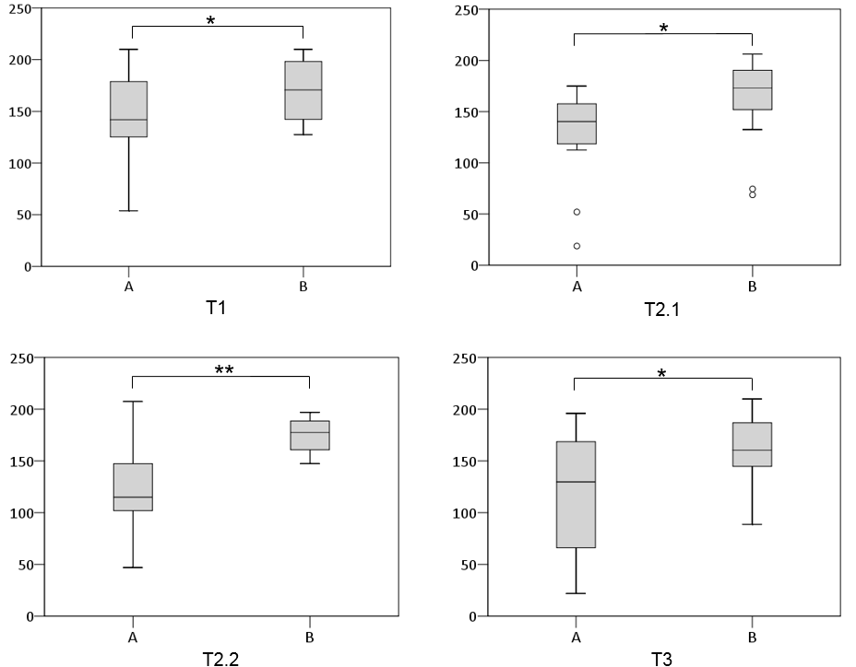

Fig. 1. ISONORM 9241/10 usability ratings by dyads over the course of the study, N = 34; ** p < .001 and * p < .05, B rated better than A by sample at all time points.

not at all good  0 | poor  1 | fair  2 | good  3 | very good  4
not at all  0 | rarely  1 | sometimes  2 | often  3 | very often  4

Product functions (asked separately):
How much did you like the: (1) telephone; (2) location function?
Design features (asked separately):
How much did you like the: (1) color; (2) font; (3) size; (4) weight; (5) buttons; (6) battery life of the product?
How satisfied were you with the product overall?
How often did you use the product overall?
NOTE. The location function was assessed by caregivers only.

Table 1. Visualization of questions at T2.1 and T3

