Supplementary Table 1: Mean ganglion cell and inner plexiform layer thicknesses of CIS patients compared matched controls.
Retinal layer | HC (matched to CIS-NON) | CIS-NON | Regression coefficient ^{a)} | Standard error ^{a)} | P-value ^{a)}
GCL [µm] | 35.14 (2.94) | 33.92 (3.57) | -1.41 | 0.72 | 0.051
IPL [µm] | 36.13 (2.93) | 34.96 (3.19) | -1.06 | 0.67 | 0.110
GCIPL [µm] | 71.27 (4.52) | 68.88 (5.52) | -2.48 | 1.12 | 0.027
Retinal layer | HC (matched to CIS-SON) | CIS-SON | Regression coefficient ^{a)} | Standard error ^{a)} | P-value ^{a)}
GCL [µm] | 35.50 (2.96) | 30.10 (3.08) | -5.18 | 1.76 | 0.003
IPL [µm] | 35.95 (2.79) | 33.05 (4.59) | -2.55 | 2.20 | 0.247
GCIPL [µm] | 71.45 (4.87) | 63.15 (7.43) | -7.62 | 3.85 | 0.048
Retinal layer | HC (matched to CIS-ON) | CIS-ON | Regression coefficient ^{a)} | Standard error ^{a)} | P-value ^{a)}
GCL [µm] | 35.45 (2.90) | 26.64 (5.35) | -8.99 | 1.48 | <0.001
IPL [µm] | 36.12 (2.97) | 32.06 (5.06) | -4.68 | 1.41 | 0.009
GCIPL [µm] | 71.57 (4.62) | 58.69 (9.77) | -13.68 | 2.64 | <0.001
Abbreviations: HC = healthy control eyes; CIS-NON = patient eyes without history of optic neuritis and VEP P100 <= 115 ms; CIS-SON = eyes with VEP P100 latency > 115 ms but no ON diagnosis; CIS-ON = patient eyes with clinical ON diagnosis; SD = standard deviation; IPL = inner plexiform layer; GCL = ganglion cell layer; GCIPL = combined ganglion cell and inner plexiform layer.
^{a)} Statistical parameters of the comparison of CIS patients to the corresponding matching controls using generalized estimation equation models.

Supplementary Figure 1: Spatial analysis of changes in the GCL and IPL.
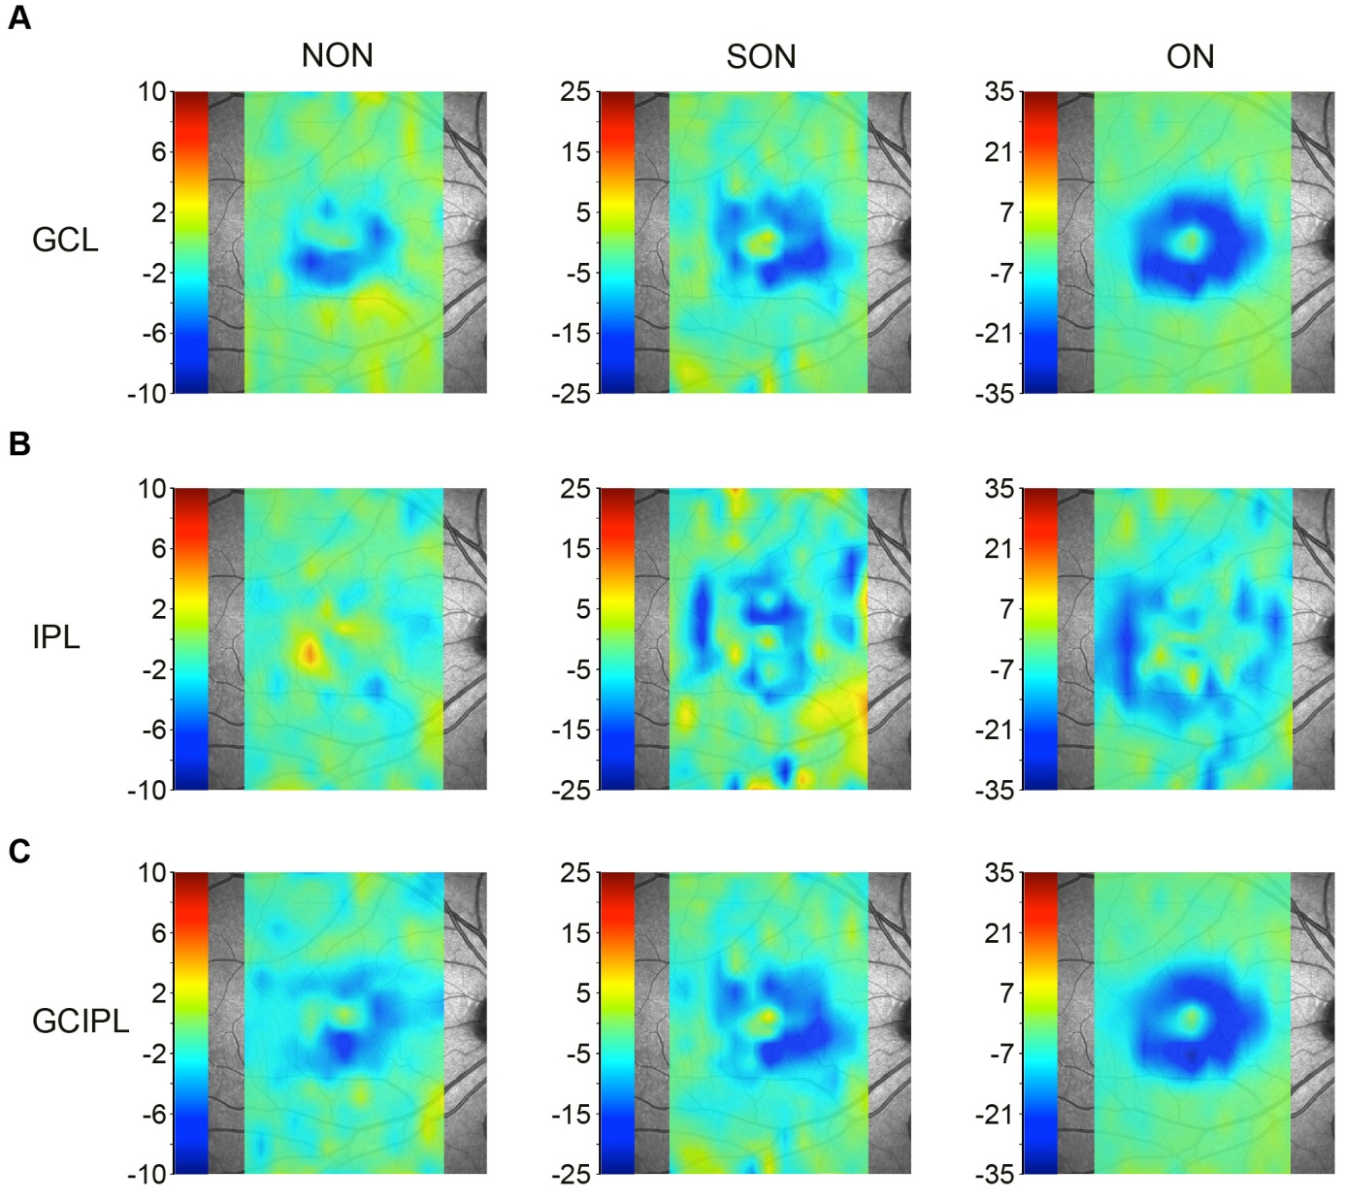
Spatial thickness changes between CIS patients and the corresponding matched healthy controls. Patients were stratified by history of ON: no history of ON (NON), suspicious for an ON (SON) or a clinically diagnosed ON. Mean thickness values and statistical analysis are summarized in eTable 1. Difference maps for A) GCL B) IPL and C) the combined GCL and IPL (GCIPL).
Abbreviations: GCL = ganglion cell layer; IPL = inner plexiform layer; GCIPL = combined ganglion cell and inner plexiform layer; INL = inner nuclear layer.

Supplementary Figure 2: Correlation of VEP P100 latencies to intra-retinal layer thicknesses
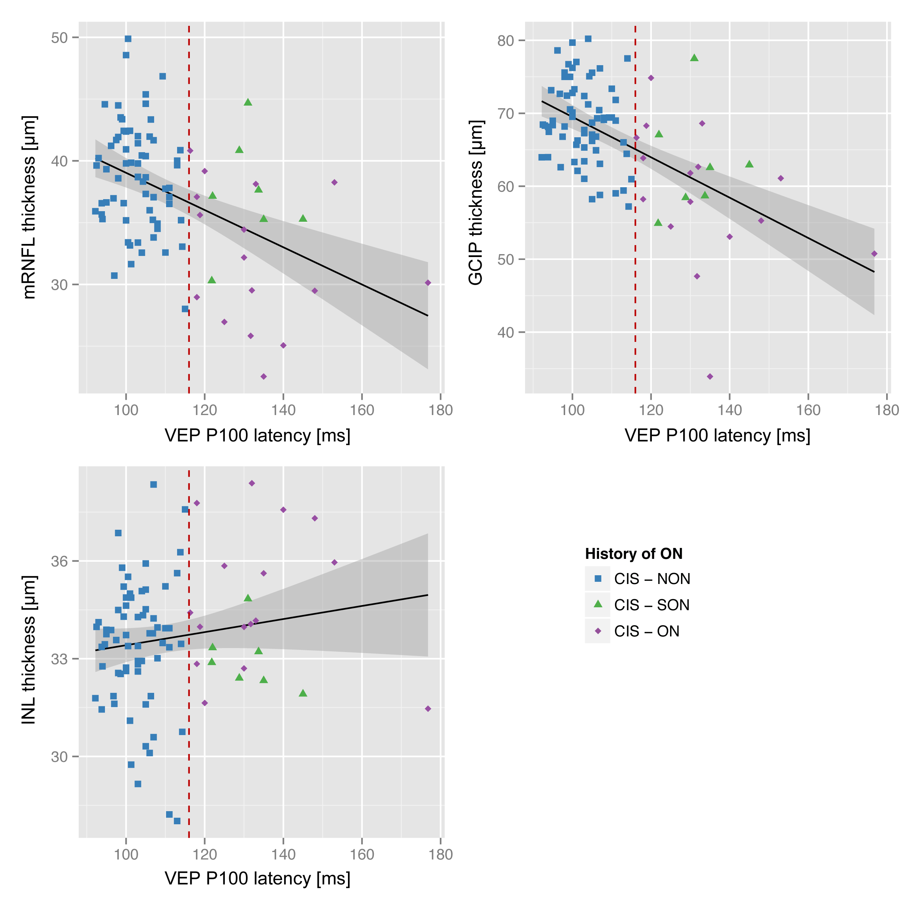

Supplementary Figure 3: Scatterplot for the relationship of time since onset with TMV and GCIP, respectively
